**PROIECT BAZE DE DATE**

**-Cinematograf-**

Farcași George-Octavian

Grupa 133

Cuprins

1.Descriere. 2

2.Constrângeri. 2

3.Entitati. 3

4.Relații. 3

5.Atribute. 4

6.Diagrama entitate-relație. 8

7.Diagrama conceptuala. 8

8.Scheme relaționale. 9

9.Forme normale. 9

10.Secvență inserare. 11

11.Crearea tabelelor și inserarea datelor. 12

12.Formulați si implementați 5 cereri SQL complexe. 67

13.Operații actualizare și suprimare. 71

15.Operația outer-join 74

# **1.Descriere.**

Un nou lanț de cinematografe a apărut, atrăgând atenția a multor iubitori de filme. Numeroase orașe din Romania au deja cate un cinematograf, oferindu-le oamenilor un nou mod de a-si petrece timpul liber. In fiecare locație deschisa sunt angajați, organizați după un program si o secțiune de lucru.

Un cinematograf este alcătuit din una sau mai multe săli, iar o sala conține mai multe locuri diferențiate printr-o litera si un număr, ce reprezintă rândul si numărul locului. Filmele au o data de lansare, un gen, un regizor si un rating. Ele sunt difuzate la diferite ore, având diferite preturi, iar sălile in care sunt redate permit intrarea clienților doar pe baza de bilet.

Clienții trebuie sa își rezerve(cumpere) biletele, fie online, fie direct la cinematograf, ele având menționat locul in sala si rezervarea. De asemenea, ei își pot achiziționa mâncare si băutură de la magazinul cinematografului, pe care le pot consuma pe parcursul filmului.

# **2.Constrângeri.**

* Rating-ul unui film este cuprins intre 1 si 10.
* Un client poate cumpăra mai multe tipuri de snacks-uri, iar un tip de snack poate fi cumpărat de mai mulți clienți, locul de unde poate cumpăra fiind magazinul cinematografului, el stocând tranzacțiile.
* Orice film are un director unic.
* Pentru un cinematograf s-a considerat ca are o unica locație, nefiind doua cinematografe cu aceeași adresa.
* Un film poate fi redat in aceeași sala de cinema decât după terminarea filmului precedent. Durata filmelor este măsurata in minute.
* Programul angajaților este de la deschiderea cinematografului, pana la închiderea lui.
* Se considera ca mereu vor fi filme de redat si angajați ce vor lucra, turele angajaților fiind cuprinse intre 4-8 ore.
* O tura poate fi comuna mai multor angajați, la fel si o secțiune de lucru, turele putând fi schimbate de la o zi la alta.
* Genurile filmelor pot fi acțiune, drama, horror, thriller, comedie, aventura, romantic, mister.
* Prețul unui bilet nu poate depăși valoarea de 100 RON, iar prețul unui snack valoarea de 60 RON.
* Pentru angajați s-a considerat salariul cuprins intre 1500-3000 RON.
* Pentru contactarea angajaților si clienților ce își cumpăra biletele online, s-a considerat cate un singur număr de telefon mobil si o singura adresa de mail.

# 

# **3.Entitati.**

|  |  |  |
| --- | --- | --- |
| **ENTITATE** | **CHEIE PRIMARA** | **DESCRIERE** |
| Filme | film_id | Entitate ce conține filmele care sunt disponibile si informații despre ele |
| Regizori | regizor_id | Persoana fizica care se ocupa principal si coordonează procesul de creare al unui film |
| Transmiteri | transmitere_id | Acțiunea efectiva de difuzare a unui film într-o sala a cinematografului |
| Sali_cinematograf | sala_id | Entitate ce conține detalii despre sălile dintr-un cinematograf |
| Clienti | client_id | Persoana fizica ce își rezerva/cumpără bilete pentru a putea viziona filme |
| Snacks-uri | snack_id | Snacks-urile din magazinul cinematografului pe care clienții le pot cumpăra si consuma pe parcursul filmului |
| Bilete | bilet_id | Informații despre biletele ce se vând într-un cinematograf, conținând locul si sala |
| Locuri_sala | loc_id | Entitate ce conține locurile dintr-o sala si poziționarea lor |
| Cinematografe | cinematograf_id | Detalii despre cinematografe precum si localizarea lor |
| Locatii | locatie_id | Entitate care identifica locația unica a unui cinematograf |
| Ture_angajati | tura_id | Entitate ce organizează programul angajaților, conține informații despre turele in care lucrează angajații |
| Sectiuni_lucru | sectiune_id | Secțiunile dintr-un cinematograf in care pot lucra angajații |
| Angajati | angajat_id | Persoana fizica ce lucrează într-o anumita secțiune din cinematograf |

# **4.Relații.**

|  |  |  |
| --- | --- | --- |
| **RELATIE** | **CARDINALITATE** | **OBSERVATII** |
| apar | 1. Filme-Transmitere: **one-to-many**  Cardinalitate minima: 1:0  Cardinalitate maxima: 1:m | 1. Un film poate apare in 0 sau mai multe transmiteri, iar o transmitere poate avea un film |
| are | 1. Locuri_sala-Bilete: **one-to-one**  Cardinalitate minima: 1:0  Cardinalitate maxima: 1:1  2. Cinematografe-Ture_angajati: **one-to-many**  Cardinalitate minima: 1:1  Cardinalitate maxima: 1:m  3. Locatii-Cinematografe: **one-to-one**  Cardinalitate minima: 1:1  Cardinalitate maxima: 1:1  4. Sali_cinematograf-Transmiteri: **one-to-many**  Cardinalitate minima: 1:0  Cardinalitate maxima: 1:m | 1. Un loc in sala poate avea cel mult un bilet atribuit, iar un bilet conține un singur loc in sala  2. Un cinematograf poate avea una sau mai multe ture pentru angajați, iar o tura poate sa fie doar intr-un cinematograf  3. Un cinematograf are o singura locatie si intr-o locatie se afla un singur cinematograf  4. O sala de cinematograf poate avea una sau mai multe transmiteri, dar o transmitere poate sa fie intr-o singura sala |
| contine | 1. Sali_cinematograf-Locuri_sala: **one-to-many**  Cardinalitate minima: 1:1  Cardinalitate maxima: 1:m  2. Cinematografe-Sali_cinematograf: **one-to-many**  Cardinalitate minima: 1:1  Cardinalitate maxima: 1:m | 1. O sala contine unul sau mai multe locuri, iar un loc poate sa fie continut intr-o singura sala  2. Un cinematograf contine una sau mai multe sali, iar o sala poate sa fie continuta intr-un singur cinematograf |
| creaza | 1. Regizori-Filme: **one-to-many**  Cardinalitate minima: 1:1  Cardinalitate maxima: 1:m | 1. Un regizor poate crea unul sau mai multe filme, iar un film poate fi creat de un singur regizor |
| cumpara | 1. Clienti-Snacks-uri: **many-to-many**  Cardinalitate minima: 0:0  Cardinalitate maxima: m:n | 1. Un client poate cumpara 0 sau mai multe tipuri de snacks-uri, iar un tip de snack poate fi cumparat de 0 sau mai multi clienti |
| lucreaza | 1. Sectiuni _lucru-Angajati: **one-to-many**  Cardinalitate minima: 1:1  Cardinalitate maxima: 1:m | 1. Un angajat lucreaza pe o singura sectiune de lucru, iar pe o sectiune poate lucra unul sau mai mulți angajați |
| organizeaza | 1. Ture_angajati-Angajati: **one-to-many**  Cardinalitate minima: 1:1  Cardinalitate maxima: 1:m | 1. Un angajat este organizat de o tura de program, iar o tura poate organiza unul sau mai mulți angajați |
| rezerva | 1. Clienti-Bilete-Transmiteri: **relatie de tip 3** | 1. Un client poate sa își rezerve mai multe bilete de la mai multe transmiteri |

# **5.Atribute.**

Entitate: Regizori

|  |  |  |  |  |
| --- | --- | --- | --- | --- |
| **ATRIBUT** | **TIP** | **DIMENSIUNE [SI NUMAR ZECIMALE]** | **VALORI POSIBILE/**  **DEFAULT** | **CONSTRANGERI** |
| regizor_id | number | 5,0 | - | PK |
| nume | varchar2 | 30 | - | NOT NULL |
| prenume | varchar2 | 40 | - | NOT NULL |

Entitate: Filme

|  |  |  |  |  |
| --- | --- | --- | --- | --- |
| **ATRIBUT** | **TIP** | **DIMENSIUNE [SI NUMAR ZECIMALE]** | **VALORI POSIBILE/**  **DEFAULT** | **CONSTRANGERI** |
| film_id | number | 5,0 | - | PK |
| regizor_id | number | 5,0 | - | FK, NOT NULL |
| nume_film | varchar2 | 50 | - | NOT NULL |
| rating | number | 1,0 | 1,2,3,4,5,6,7,8,9,10 | CHECK, NOT NULL |
| gen | varchar2 | 10 | acțiune, drama, horror, thriller, comedie, aventura, romantic, mister | CHECK, NOT NULL |
| data_lansare | date | - | - | NOT NULL |
| durata | number | 3 ,0 | - | NOT NULL |

Entitate: Transmiteri

|  |  |  |  |  |
| --- | --- | --- | --- | --- |
| **ATRIBUT** | **TIP** | **DIMENSIUNE [SI NUMAR ZECIMALE]** | **VALORI POSIBILE/**  **DEFAULT** | **CONSTRANGERI** |
| transmitere_id | number | 5,0 | - | PK |
| film_id | number | 5,0 | - | FK,UNIQUE, NOT NULL |
| sala_id | number | 5,0 | - | FK,UNIQUE, NOT NULL |
| data_ora_incepere | varchar2 | 50 | SYSDATE | UNIQUE |
| pret | number | 5,2 | [0,100] | NOT NULL, CHECK |

Entitate: Sali_cinematograf

|  |  |  |  |  |
| --- | --- | --- | --- | --- |
| **ATRIBUT** | **TIP** | **DIMENSIUNE [SI NUMAR ZECIMALE]** | **VALORI POSIBILE/**  **DEFAULT** | **CONSTRANGERI** |
| sala_id | number | 5,0 | - | PK |
| cinematograf_id | number | 5,0 | - | FK, NOT NULL |
| capacitate | number | 3,0 | [1,150] | CHECK, NOT NULL |

Entitate: Clienti

|  |  |  |  |  |
| --- | --- | --- | --- | --- |
| **ATRIBUT** | **TIP** | **DIMENSIUNE [SI NUMAR ZECIMALE]** | **VALORI POSIBILE/**  **DEFAULT** | **CONSTRANGERI** |
| client_id | number | 5,0 | - | PK |
| nume_client | varchar2 | 30 | - | NOT NULL |
| prenume_client | varchar2 | 40 | - | - |
| telefon | varchar2 | 20 | - | UNIQUE |
| email | varchar2 | 30 | - | NOT NULL, UNIQUE |

Entitate: Snacks-uri

|  |  |  |  |  |
| --- | --- | --- | --- | --- |
| **ATRIBUT** | **TIP** | **DIMENSIUNE [SI NUMAR ZECIMALE]** | **VALORI POSIBILE/**  **DEFAULT** | **CONSTRANGERI** |
| snack_id | number | 5,0 | - | PK |
| nume_snack | varchar2 | 30 | - | NOT NULL |
| pret | number | 4,2 | [0,60] | NOT NULL |

Entitate: Bilete

|  |  |  |  |  |
| --- | --- | --- | --- | --- |
| **ATRIBUT** | **TIP** | **DIMENSIUNE [SI NUMAR ZECIMALE]** | **VALORI POSIBILE/**  **DEFAULT** | **CONSTRANGERI** |
| bilet_id | number | 5,0 | - | PK |
| loc_id | number | 5,0 | - | FK,UNIQUE, NOT NULL |

Entitate: Locuri_sala

|  |  |  |  |  |
| --- | --- | --- | --- | --- |
| **ATRIBUT** | **TIP** | **DIMENSIUNE [SI NUMAR ZECIMALE]** | **VALORI POSIBILE/**  **DEFAULT** | **CONSTRANGERI** |
| loc_id | number | 5,0 | - | PK |
| sala_id | number | 5,0 | - | FK, UNIQUE, NOT NULL |
| litera_rand | varchar2 | 1 | - | NOT NULL, UNIQUE |
| numar_loc | number | 3,0 | - | NOT NULL, UNIQUE |

Entitate: Cinematografe

|  |  |  |  |  |
| --- | --- | --- | --- | --- |
| **ATRIBUT** | **TIP** | **DIMENSIUNE [SI NUMAR ZECIMALE]** | **VALORI POSIBILE/**  **DEFAULT** | **CONSTRANGERI** |
| cinematograf_id | number | 5,0 | - | PK |
| locatie_id | number | 5,0 | - | FK, NOT NULL |
| numar_sali | number | 2,0 | >=1 | CHECK, NOT NULL |

Entitate: Locatii

|  |  |  |  |  |
| --- | --- | --- | --- | --- |
| **ATRIBUT** | **TIP** | **DIMENSIUNE [SI NUMAR ZECIMALE]** | **VALORI POSIBILE/**  **DEFAULT** | **CONSTRANGERI** |
| locatie_id | number | 5,0 | - | PK |
| strada | varchar2 | 30 | - | NOT NULL, UNIQUE |
| localitate | varchar2 | 30 | - | NOT NULL, UNIQUE |
| judet | varchar2 | 30 | - | NOT NULL, UNIQUE |

Entitate: Ture_angajați

|  |  |  |  |  |
| --- | --- | --- | --- | --- |
| **ATRIBUT** | **TIP** | **DIMENSIUNE [SI NUMAR ZECIMALE]** | **VALORI POSIBILE/**  **DEFAULT** | **CONSTRANGERI** |
| tura_id | number | 5,0 | - | PK |
| cinematograf_id | number | 5,0 | - | FK, NOT NULL |
| ora_incepere | varchar2 | 30 | SYSDATE | - |
| durata | number | 1,0 | 4,5,6,7,8 | CHECK, NOT NULL |

Entitate: Sectiuni_lucru

|  |  |  |  |  |
| --- | --- | --- | --- | --- |
| **ATRIBUT** | **TIP** | **DIMENSIUNE [SI NUMAR ZECIMALE]** | **VALORI POSIBILE/**  **DEFAULT** | **CONSTRANGERI** |
| sectiune_id | number | 5,0 | - | NOT NULL |
| nume_sectiune | varchar2 | 30 | - | UNIQUE, NOT NULL |

Entitate: Angajati

|  |  |  |  |  |
| --- | --- | --- | --- | --- |
| **ATRIBUT** | **TIP** | **DIMENSIUNE [SI NUMAR ZECIMALE]** | **VALORI POSIBILE/**  **DEFAULT** | **CONSTRANGERI** |
| angajat_id | number | 5,0 | - | PK |
| sectiune_id | number | 5,0 | - | FK, NOT NULL |
| tura_id | number | 5,0 | - | FK, NOT NULL |
| nume_angajat | varchar2 | 30 | - | NOT NULL |
| prenume_angajat | varchar2 | 40 | - | NOT NULL |
| salariu | number | 6,2 | [1500-3000] | CHECK, NOT NULL |
| telefon | varchar2 | 20 | - | UNIQUE, NOT NULL |

Relatia: Client_cumpara_Snacks-uri

|  |  |  |  |  |
| --- | --- | --- | --- | --- |
| **ATRIBUT** | **TIP** | **DIMENSIUNE [SI NUMAR ZECIMALE]** | **VALORI POSIBILE/**  **DEFAULT** | **CONSTRANGERI** |
| client_id | number | 5,0 | - | PK, FK |
| snack_id | number | 5,0 | - | PK, FK |
| data | date | - | SYSDATE | - |

Relatia: Client_rezerva_Bilete_la_Transmiteri

|  |  |  |  |  |
| --- | --- | --- | --- | --- |
| **ATRIBUT** | **TIP** | **DIMENSIUNE [SI NUMAR ZECIMALE]** | **VALORI POSIBILE/**  **DEFAULT** | **CONSTRANGERI** |
| client_id | number | 5,0 | - | PK, FK |
| transmitere_id | number | 5,0 | - | PK, FK, UNIQUE |
| bilet_id | number | 5,0 | - | PK, FK, UNIQUE |

# **6.Diagrama entitate-relație.**

# **7.Diagrama conceptuala.**

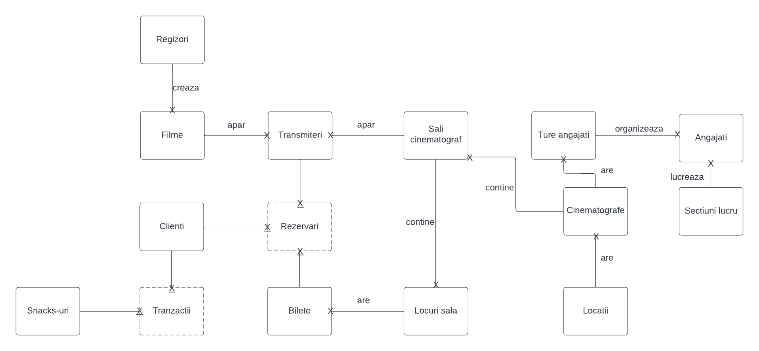

# **8.Scheme relaționale.**

* **REGIZORI**(regizor_id#, nume, prenume);
* **FILME**(film_id#, regizor_id, nume_film, rating, gen, data_lansare, durata);
* **TRANSMITERI**(transmitere_id#, film_id, sala_id, data_ora_incepere, pret);
* **SALI_CINEMATOGRAF**(sala_id#, cinematograf_id, capacitate);
* **CLIENTI**(client_id#, nume_client, prenume_client, telefon, email);
* **SNACKS-URI**(snack_id#, nume_snack, pret);
* **BILETE**(bilet_id#, loc_id);
* **LOCURI_SALA**(loc_id#, sala_id, litera_rand, numar_loc);
* **CINEMATOGRAFE**(cinematograf_id#, locatie_id, numar_sali);
* **LOCATII**(locatie_id#, strada, localitate, judet);
* **TURE_ANGAJATI**(tura_id#, cinematograf_id, ora_incepere, durata);
* **SECTIUNI_LUCRU**(sectiune_id#, nume_sectiune);
* **ANGAJATI**(angajat_id#, sectiune_id, tura_id, nume_angajat, prenume_angajat, salariu, telefon);
* **TRANZACTII**(client_id#, snack_id#, data);
* **REZERVARI**(client_id#, transmitere_id#, bilet_id#);

# **9.Forme normale.**

**FN1**: O relatie este in FN1 daca oricare dintre atributele tabelului contine numai valori atomice.

Un contra-exemplu poate fi tabela Regizori care avea atributele regizor_id, nume_regizor, prenume_regizor, filme_create, iar filme_create putea sa aiba mai multe valori.

Regizori

regizor_id#

nume_regizor

prenume_regizor

filme_create

Dupa aducerea la FN1, vechea tabela Regizori s-a transformat in 2 tabele diferite, tabela Regizor, ce contine informatii despre regizori si tabela Filme ce contine informatii despre filme, continand si cheia primara a tabelei Regizori.

Filme

film_id#

regizor_id

nume_film

rating

gen

data_lansare

durata

Regizori

regizor_id#

nume_regizor

prenume_regizor

filme_create

**FN2:** O relatie este in FN2 daca este in FN1 si toate atributele ce nu sunt chei primare depind in totalitate de cheia primara a tabelei din care fac parte.

Un contra exemplu poate fi gasit in tabela Tranzactii, ce contine urmatoarele atribute: client_id#, snack_id#, nume_snack, pret, iar client_id este cheia primara a tabelei Clienti. In acest exemplu, unele atribute din tabela Tranzactii depind partial de cheia primara, si anume nume_snack si pret depind doar de snack_id, nu si de client_id, deci aceasta tabela nu este in FN2.

Tranzactii

client_id#

snack_id#

nume_snack

pret

Clienti

client_id#

nume_client

prenume_client

...

Pentru a aduce tabela in FN2, ea trebuie descompusa in alte doua tabele, Tranzactii, ce contine urmatoarele atribute: client_id#, snack_id#, data, si Snacks-uri formate din atributele: snack_id#, nume_snack, pret.

Dupa aducerea la FN2, vechile tabele vor arata:

Snacks-uri

snack_id#

nume_snack

pret

Tranzactii

client_id#

snack_id#

data

Clienti

client_id#

nume_client

prenume_client

...

**FN3:** O relatie este in FN3 daca este in FN2 si fiecare atribut ce nu este, sau nu participa la cheia primara, depinde direct de cheia primara a tabelei, neexistand dependente tranzitive.

Un contra exemplu poate fi gasit in tabela Angajati, ce contine informatii despre angajati si programul lor: angajat_id#, nume_angajat, prenume_angajat, tura_id, ora_incepere_tura, durata_tura, cinematograf_id, cinematograf_id fiind cheia primara a tabelei Cinematografe. Se poate observa ca nu toate atributele depind direct de cheia primara a tabelei, mai exact ora_incepere_tura, durata_tura, cinematograf_id depind de atributul tura_id, iar tura_id depinde de cheia primara, deci aceasta tabela nu este in FN3.

Angajati

angajat_id#

...

tura_id

ora_incepere_tura

durata_tura

cinematograf_id

Pentru a aduce tabela in FN3, ea trebuie descompusa in alte doua tabele, Angajati, ce contine informatii despre angajati si Ture_angajati, ce contine informatii despre turele in care lucreaza angajatii.

Dupa aducerea la FN3, vechea tabela va arata:

Angajati

angajat_id#

nume_angajat

prenume_angajat

tura_id

...

Ture_angajati

tura_id#

ora_incepere_tura

durata_tura

cinematograf_id

# **10.Secvență inserare.**

create sequence seq_id_pt_toate

start with 1

maxvalue 10000

nocycle

nocache;

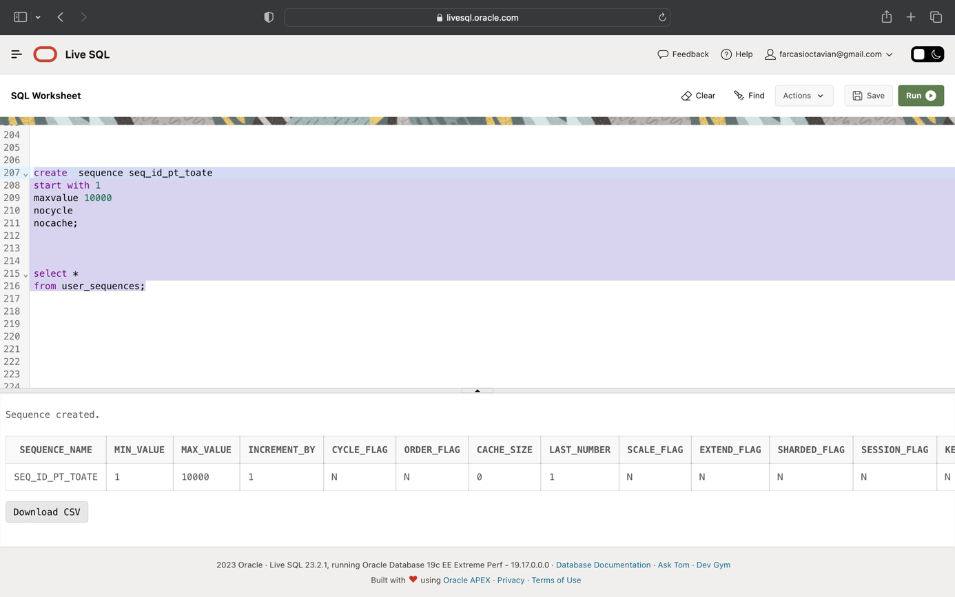

# **11.Crearea tabelelor și inserarea datelor.**

create table Regizori(

regizor_id number(5) constraint pk_regizor primary key,

nume_regizor varchar2(30) constraint null_nume_regizor not null,

prenume_regizor varchar2(30) constraint null_prenume_regizor not null

);

create table Filme(

film_id number(5) constraint pk_film primary key,

nume_film varchar2(30) constraint null_nume_film not null,

regizor_id number(5) constraint null_regizor_filme not null,

rating number(2) constraint null_rating_film not null,

gen varchar2(10) constraint null_gen_film not null,

data_lansare date constraint null_data_film not null,

durata number(3) constraint null_durata_film not null,

constraint fk_regizor_filme foreign key (regizor_id) references regizori(regizor_id) on delete cascade,

constraint check_rating_film check(1<=rating and rating<=10),

constraint check_gen_film check(lower(gen) in ('actiune','drama','horror','thriller','comedie','aventura','romantic','mister')) );

create table Clienti(

client_id number(5) constraint pk_client primary key,

nume_client varchar2(30) constraint null_nume_client not null,

prenume_client varchar2(40),

telefon varchar2(20) constraint unq_telefon_client unique,

email varchar2(30) constraint null_email_client not null,

constraint unq_email_client unique(email)

);

create table Snacks_uri(

snack_id number(5) constraint pk_snack primary key,

nume_snack varchar2(30) constraint null_nume_snack not null,

pret number(4,2) constraint null_pret_snack not null,

constraint check_pret_snack check(pret>=0 and pret<=60)

);

create table Tranzactii(

client_id number(5) constraint fk_client_tranzactii references clienti(client_id) on delete cascade,

snack_id number(5) constraint fk_snack_tranzactii references snacks_uri(snack_id) on delete cascade,

data date default sysdate,

constraint pk_tranzactie primary key(client_id,snack_id) );

create table Sectiuni_lucru(

sectiune_id number(5) constraint pk_sectiune primary key,

nume_sectiune varchar2(30) constraint null_nume_sectiuni not null,

constraint unq_nume_sectiune unique(nume_sectiune)

);

create table Locatii(

locatie_id number(5) constraint pk_locatie primary key,

strada varchar2(30) constraint null_strada_locatie not null,

localitate varchar2(30) constraint null_localitate_locatie not null,

judet varchar2(30) constraint null_judet_locatie not null,

constraint unq_StrLocJud unique(strada,localitate,judet)

);

create table Cinematografe(

cinematograf_id number(5) constraint pk_cinematograf primary key,

locatie_id number(5) constraint null_locatie_cinematografe not null,

numar_sali number(2) constraint null_numar_sali not null,

constraint fk_locatie_cinematografe foreign key (locatie_id) references locatii(locatie_id) on delete cascade,

constraint check_nrsali_cinematograf check(numar_sali>=1) );

create table Ture_angajati(

tura_id number(5) constraint pk_tura primary key,

cinematograf_id number(5) constraint null_cinematograf_ture not null,

ora_incepere varchar2(30) default to_char(sysdate,'hh24:mi'),

durata number(1) constraint null_durata_ture not null,

constraint fk_cinematograf_ture foreign key (cinematograf_id) references cinematografe(cinematograf_id) on delete cascade,

constraint check_durata_ture check(durata in (4,5,6,7,8))

);

create table Angajati(

angajat_id number(5) constraint pk_angajat primary key,

sectiune_id number(5) constraint null_sectiune_angajati not null,

tura_id number(5) constraint null_tura_angajati not null,

nume_angajat varchar2(30) constraint null_nume_angajati not null,

prenume_angajat varchar2(40) constraint null_prenume_angajati not null,

salariu number(6,2) constraint null_salariu_angajati not null,

telefon varchar2(20) constraint null_telefon_angajati not null,

constraint fk_sectiune_angajati foreign key (sectiune_id) references sectiuni_lucru(sectiune_id) on delete cascade,

constraint fk_tura_angajati foreign key (tura_id) references ture_angajati(tura_id) on delete cascade,

constraint check_salariu_angajati check(1500<=salariu and salariu<=3000),

constraint unq_telefon_angajati unique(telefon)

);

create table Sali_cinematograf(

sala_id number(5) constraint pk_sala primary key,

cinematograf_id number(5) constraint null_cinematograf_sali not null,

capacitate number(3) constraint null_capacitate_sali not null,

constraint fk_cinematograf_sali foreign key (cinematograf_id) references cinematografe(cinematograf_id) on delete cascade,

constraint check_capacitate_sali check(1<=capacitate and capacitate<=150)

);

create table Transmiteri(

transmitere_id number(5) constraint pk_transmitere primary key,

film_id number(5) constraint null_film_transmiteri not null,

sala_id number(5) constraint null_sala_transmiteri not null,

data_ora_incepere varchar2(50) default to_char(sysdate,'dd-mm-yyyy, hh24:mi'),

pret number(5,2) constraint null_pret_transmiteri not null,

constraint fk_film_transmiteri foreign key (film_id) references filme(film_id) on delete cascade,

constraint fk_sala_transmiteri foreign key (sala_id) references sali_cinematograf(sala_id) on delete cascade,

constraint check_pret_transmiteri check(0<=pret and pret<=100),

constraint unq_film_sala_data unique(film_id,sala_id, data_ora_incepere)

);

create table Locuri_sala(

loc_id number(5) constraint pk_loc primary key,

sala_id number(5) constraint null_sala_locuri not null,

litera_rand varchar2(1) constraint null_litera_locuri not null,

numar_loc number(3) constraint null_numar_locuri not null,

constraint fk_sala_locuri foreign key (sala_id) references sali_cinematograf(sala_id) on delete cascade,

constraint unq_sala_litera_numar unique(sala_id,litera_rand,numar_loc)

);

create table Bilete(

bilet_id number(5) constraint pk_bilet primary key,

loc_id number(5) constraint null_loc_bilete not null,

constraint fk_loc_bilete foreign key (loc_id) references locuri_sala(loc_id) on delete cascade,

constraint unq_loc_bilete unique(loc_id)

);

create table Rezervari(

client_id number(5) constraint fk_client_rezervari references clienti(client_id) on delete cascade,

transmitere_id number(5) constraint fk_transmitere_rezervari references transmiteri(transmitere_id) on delete cascade,

bilet_id number(5) constraint fk_bilet_rezervari references bilete(bilet_id) on delete cascade,

constraint pk_rezervare primary key(client_id,transmitere_id,bilet_id),

constraint unq_transmitere_bilet unique(transmitere_id,bilet_id)

);

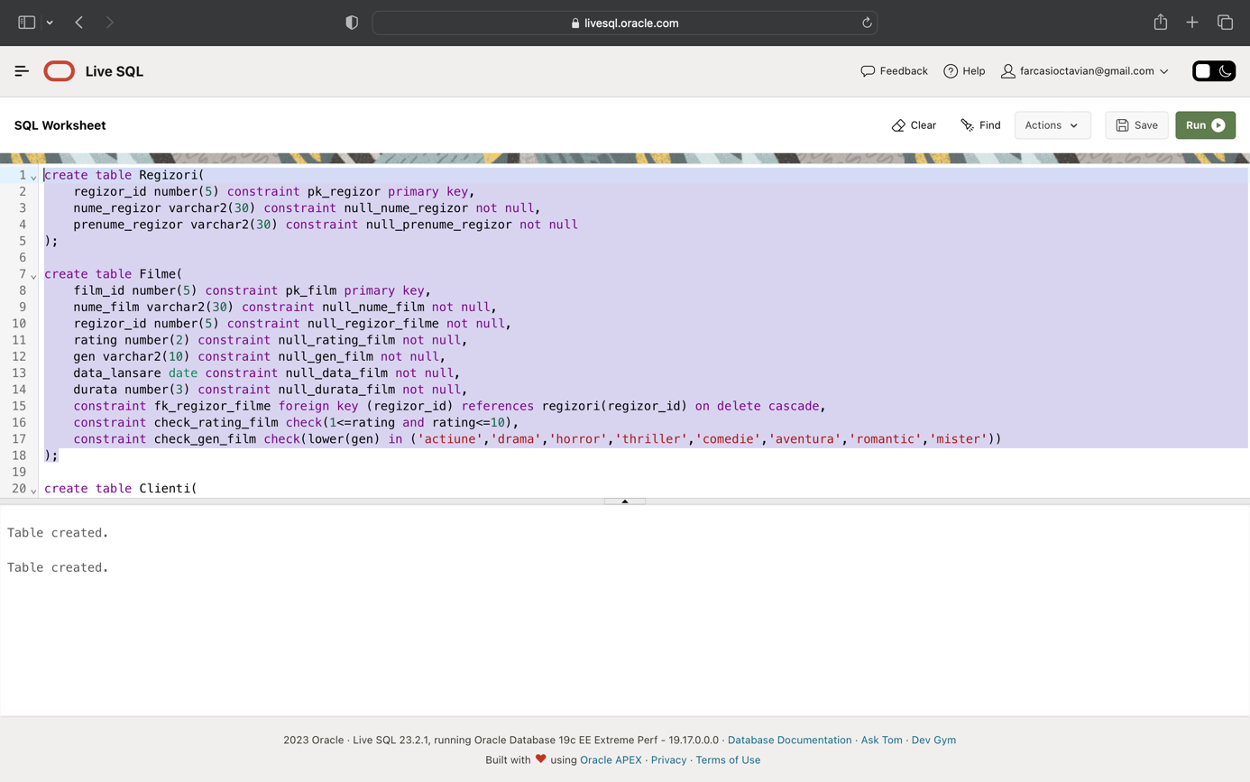

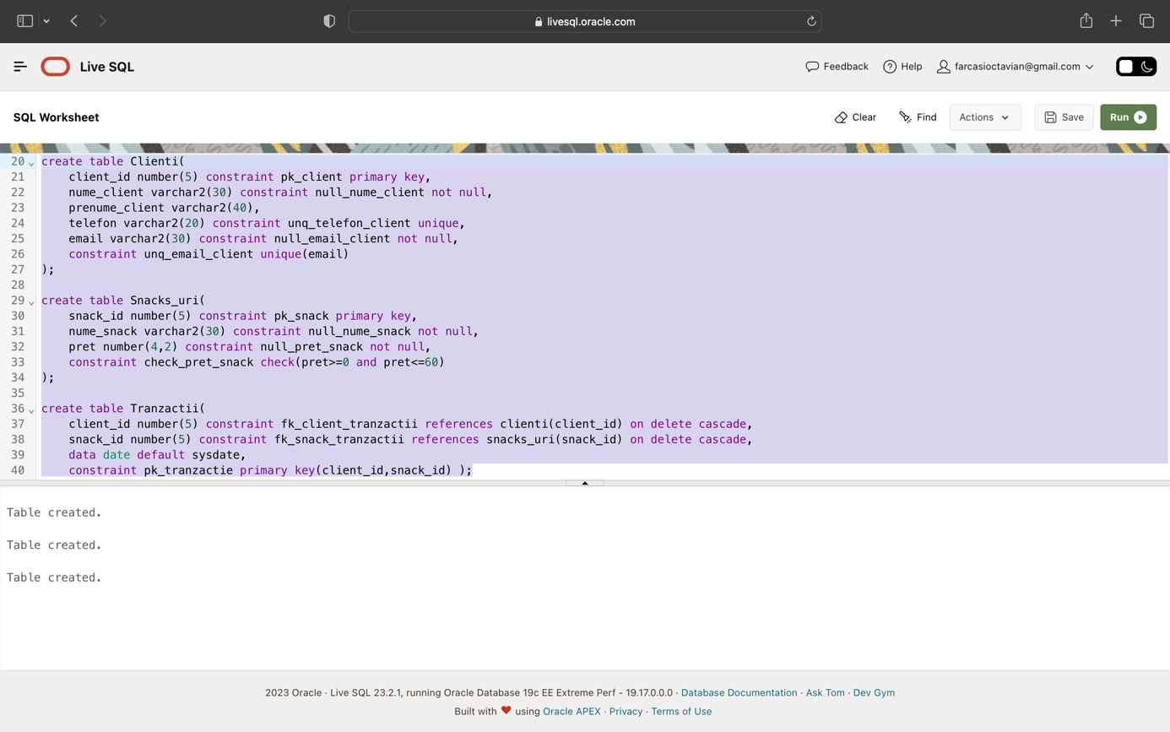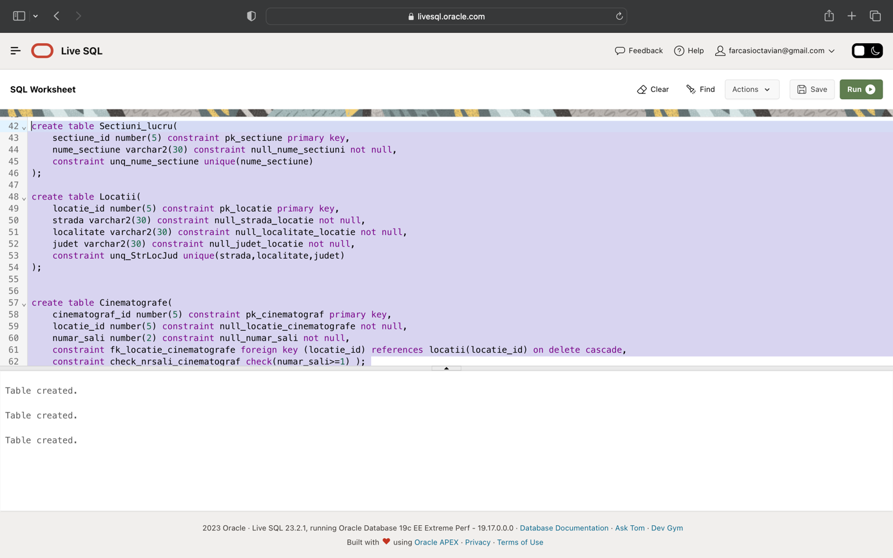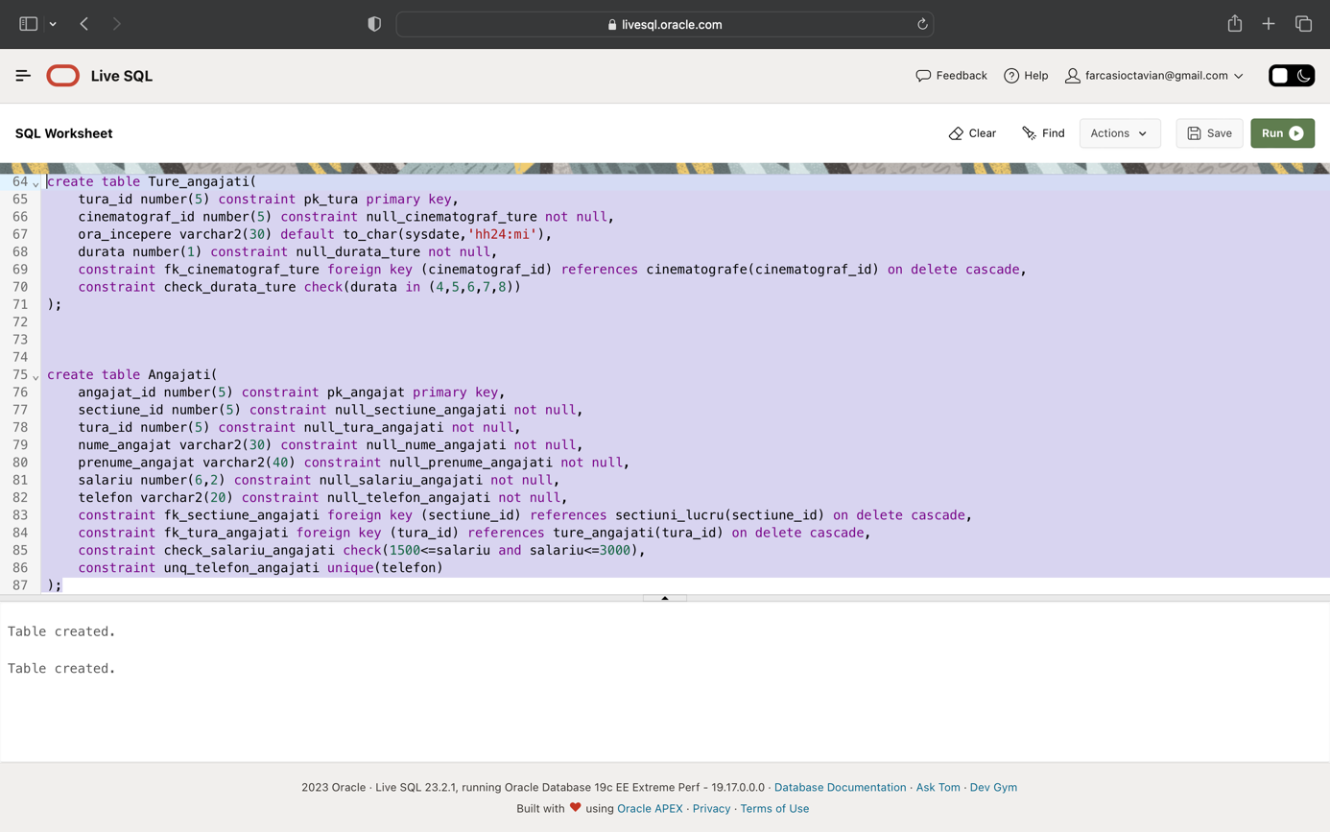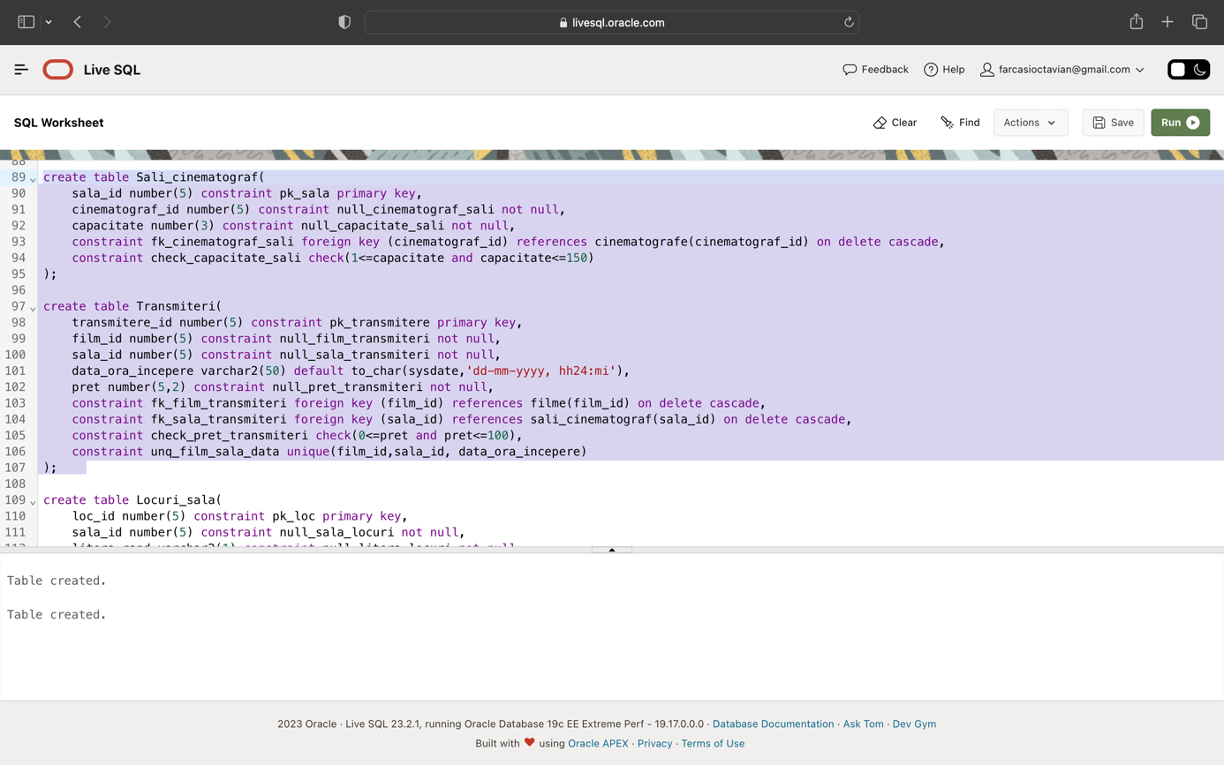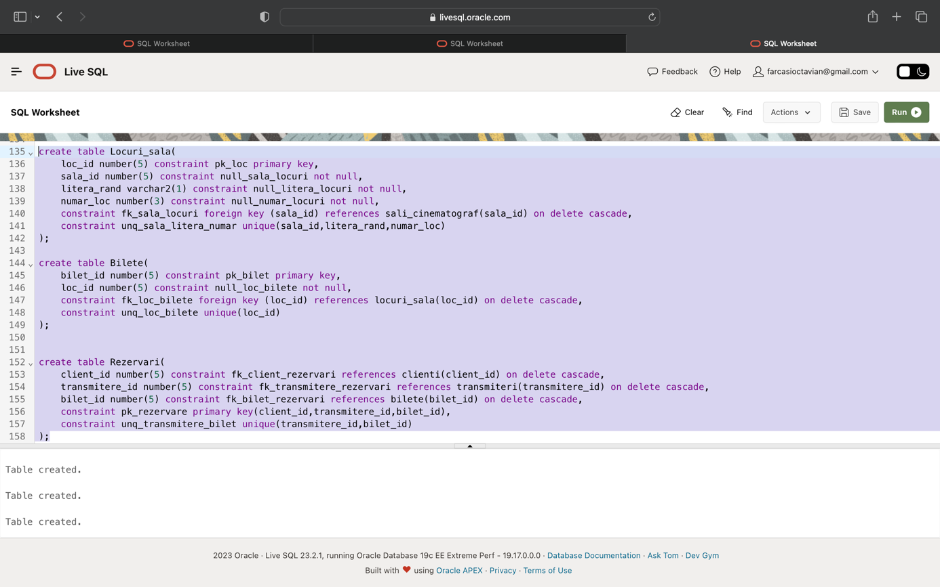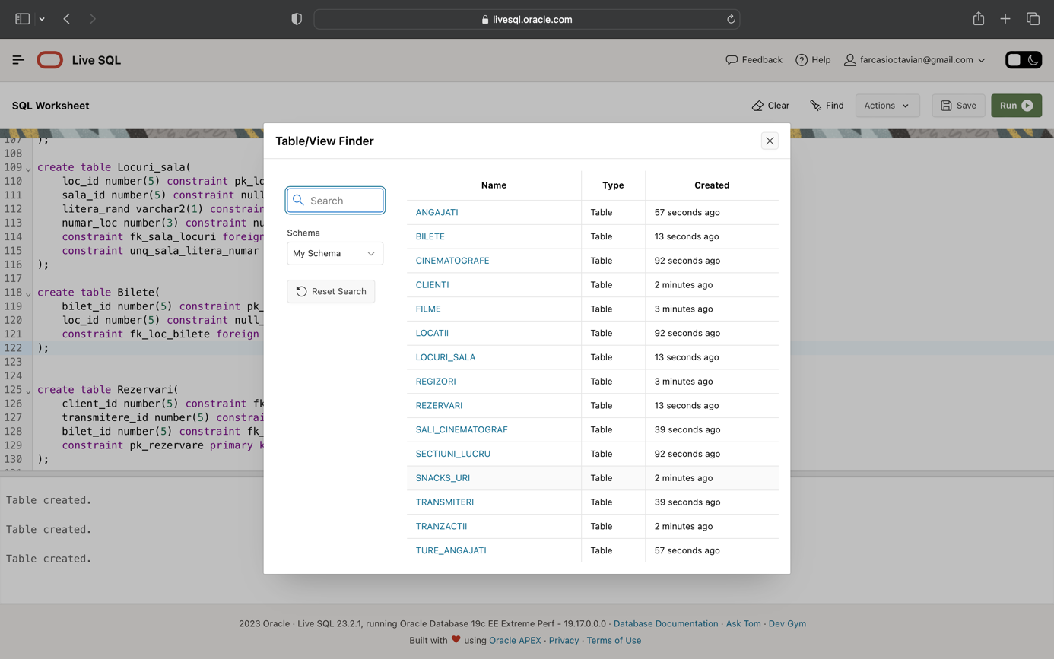

insert into regizori

values(seq_id_pt_toate.nextval,'Kosinski', 'Joseph');

insert into regizori

values(seq_id_pt_toate.nextval,'Harron', 'Mary');

insert into regizori

values(seq_id_pt_toate.nextval,'Shadyac', 'Tom');

insert into regizori

values(seq_id_pt_toate.nextval,'Stahelski', 'Chad');

insert into regizori

values(seq_id_pt_toate.nextval,'Wachowsky', 'Lana');

insert into regizori

values(seq_id_pt_toate.nextval,'Cretton', 'Destin');

insert into regizori

values(seq_id_pt_toate.nextval,'Cunningham', 'Sean');

insert into regizori

values(seq_id_pt_toate.nextval,'Nolan', 'Christopher');

insert into regizori

values(seq_id_pt_toate.nextval,'Bier', 'Susanne');

insert into regizori

values(seq_id_pt_toate.nextval,'Krasinski', 'John');

insert into regizori

values(seq_id_pt_toate.nextval,'Russo', 'Anthony');

insert into regizori

values(seq_id_pt_toate.nextval,'Watts', 'Jon');

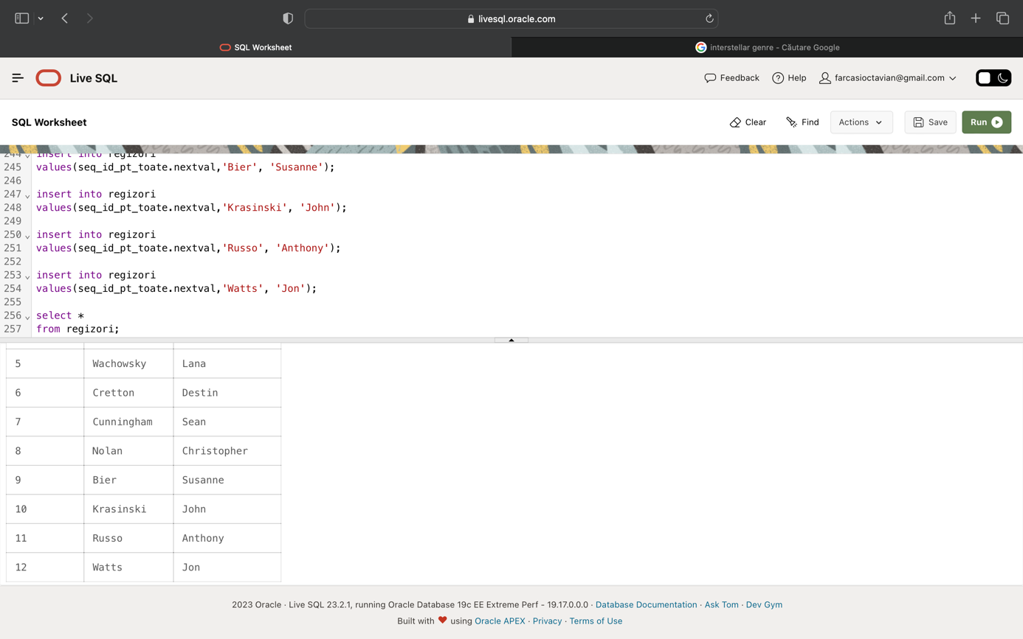

alter sequence seq_id_pt_toate restart;

insert into filme

values(seq_id_pt_toate.nextval,'The Dark Knight',8,9,'actiune',to_date('25-07-2008', 'dd-mm-yyyy'),152);

insert into filme

values(seq_id_pt_toate.nextval,'Interstellar',8,9,'aventura',to_date('07-11-2014', 'dd-mm-yyyy'),169);

insert into filme

values(seq_id_pt_toate.nextval,'Top Gun: Maverick',1,8,'actiune',to_date('27-05-2022', 'dd-mm-yyyy'),131);

insert into filme

values(seq_id_pt_toate.nextval,'American Psycho',2,8,'drama',to_date('14-04-2000', 'dd-mm-yyyy'),102);

insert into filme

values(seq_id_pt_toate.nextval,'Ace Ventura: Pet Detective',3,7,'comedie',to_date('04-02-1994', 'dd-mm-yyyy'),86);

insert into filme

values(seq_id_pt_toate.nextval,'John Wick',4,8,'actiune',to_date('31-10-2014', 'dd-mm-yyyy'),101);

insert into filme

values(seq_id_pt_toate.nextval,'The Matrix',5,9,'actiune',to_date('31-03-1999', 'dd-mm-yyyy'),136);

insert into filme

values(seq_id_pt_toate.nextval,'Shang-Chi',6,7,'actiune',to_date('02-09-2021', 'dd-mm-yyyy'),132);

insert into filme

values(seq_id_pt_toate.nextval,'Friday the 13th',7,6,'horror',to_date('09-05-1980', 'dd-mm-yyyy'),95);

insert into filme

values(seq_id_pt_toate.nextval,'Bird Box',9,7,'horror',to_date('14-12-2018', 'dd-mm-yyyy'),124);

insert into filme

values(seq_id_pt_toate.nextval,'A Quiet Place Part II',10,7,'horror',to_date('28-05-2021', 'dd-mm-yyyy'),107);

insert into filme

values(seq_id_pt_toate.nextval,'Avengers Endgame',11,9,'actiune',to_date('26-04-2019', 'dd-mm-yyyy'),182);

insert into filme

values(seq_id_pt_toate.nextval,'Spider-Man: No Way Home',12,8,'actiune',to_date('17-12-2021', 'dd-mm-yyyy'),148);

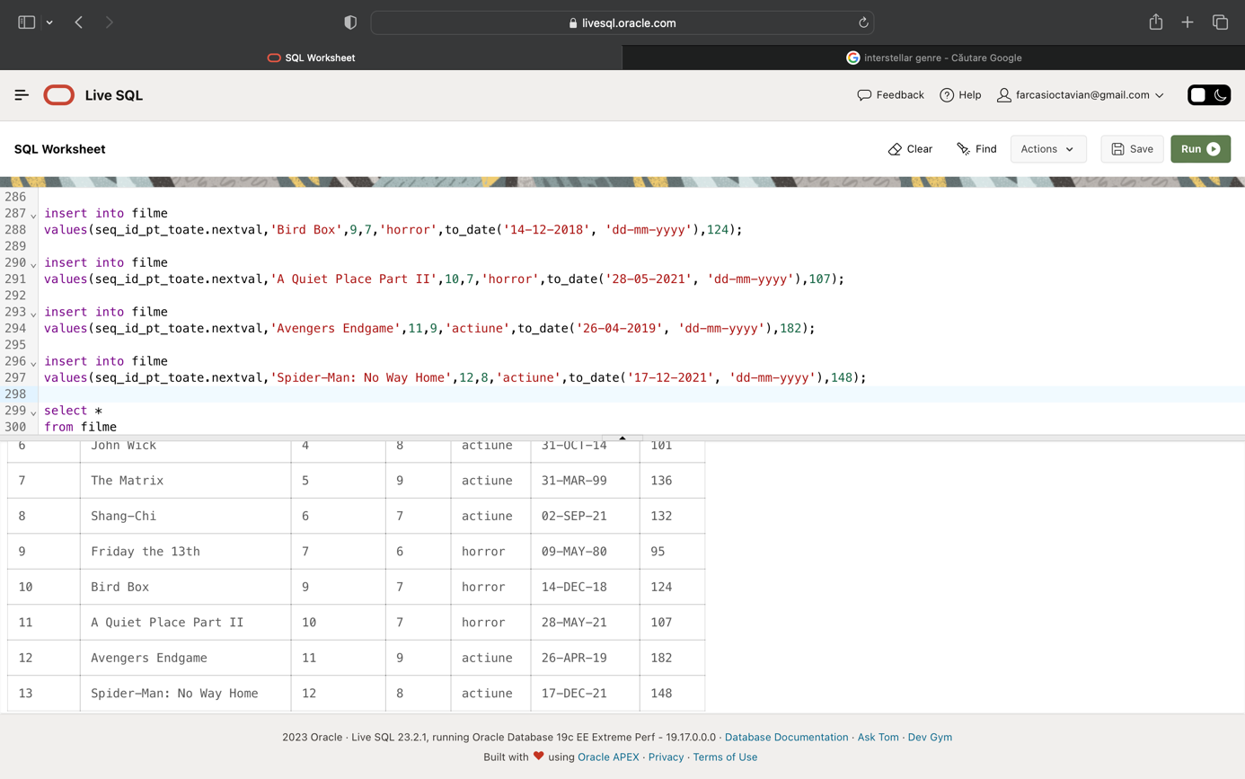

alter sequence seq_id_pt_toate restart;

insert into clienti

values(seq_id_pt_toate.nextval,'Anghel','Robert','7013.994.277','anghelrobert@gmail.com');

insert into clienti

values(seq_id_pt_toate.nextval,'Serban','Cezar','9774.857.343','serbancezar@gmail.com');

insert into clienti

values(seq_id_pt_toate.nextval,'Ionescu','Ion','8183.292.531','ionescuion@gmail.com');

insert into clienti

values(seq_id_pt_toate.nextval,'Stoica','Andreea','2235.414.416','stoicaandreea@gmail.com');

insert into clienti

values(seq_id_pt_toate.nextval,'Ionescu','Medeea','1481.482.726','ionescumedeea@gmail.com');

insert into clienti

values(seq_id_pt_toate.nextval,'Sovei','Catalin','4843.349.707','sovei24catalin@gmail.com');

insert into clienti

values(seq_id_pt_toate.nextval,'Farcasi','Alexia','9522.866.886','farcasialexia@gmail.com');

insert into clienti

values(seq_id_pt_toate.nextval,'Serban','Violeta','7624.823.234','serbanvioleta@gmail.com');

insert into clienti

values(seq_id_pt_toate.nextval,'Antonescu','Catalin','5656.194.221','antonescucatalin@gmail.com');

insert into clienti

values(seq_id_pt_toate.nextval,'Popescu','Andreea','1535.279.858','popescuandreea@gmail.com');

insert into clienti

values(seq_id_pt_toate.nextval,'Ionescu','Catalin','2265.691.445','ionescucatalin@gmail.com');

insert into clienti

values(seq_id_pt_toate.nextval,'Mircea','Ion','5389.488.939','mirceaion@gmail.com');

insert into clienti

values(seq_id_pt_toate.nextval,'Vladileanu','Andrei','8532.837.501','vladileanuandrei@gmail.com');

insert into clienti

values(seq_id_pt_toate.nextval,'Antonescu','Doina','3213.955.494','antonescudoina@gmail.com');

insert into clienti

values(seq_id_pt_toate.nextval,'Sovei','Catalin','3987.471.823','soveicatalin@gmail.com');

insert into clienti

values(seq_id_pt_toate.nextval,'Antonescu','Daniel','2031.861.516','antonescudaniel@gmail.com');

insert into clienti

values(seq_id_pt_toate.nextval,'Ionescu','Violeta','2273.523.916','ionescuvioleta@gmail.com');

insert into clienti

values(seq_id_pt_toate.nextval,'Popa','Medeea','5616.358.602','popamedeea@gmail.com');

insert into clienti

values(seq_id_pt_toate.nextval,'Antonescu','Robert','2030.474.801','antonescurobert@gmail.com');

insert into clienti

values(seq_id_pt_toate.nextval,'Ghergu','Matei','4560.905.729','ghergumatei18@gmail.com');

insert into clienti

values(seq_id_pt_toate.nextval,'Popescu','Violeta','2712.943.261','popescuvioleta@gmail.com');

insert into clienti

values(seq_id_pt_toate.nextval,'Ghergu','Matei','3744.688.842','ghergumatei@gmail.com');

insert into clienti

values(seq_id_pt_toate.nextval,'Ghergu','Doina','9246.806.630','ghergudoina@gmail.com');

insert into clienti

values(seq_id_pt_toate.nextval,'Sovei','Medeea','6468.923.930','soveimedeea@gmail.com');

insert into clienti

values(seq_id_pt_toate.nextval,'Cotofana','Luciana','7500.174.667','cotofanaluciana@gmail.com');

insert into clienti(client_id,nume_client,prenume_client,email)

values(seq_id_pt_toate.nextval,'Cotofana','Robert','cotofana12robert@yahoo.com');

insert into clienti(client_id,nume_client,prenume_client,email)

values(seq_id_pt_toate.nextval,'Ghergu','Ion','ghergu8ion@yahoo.com');

insert into clienti(client_id,nume_client,prenume_client,email)

values(seq_id_pt_toate.nextval,'Popa','Cezar','popa12cezar@yahoo.com');

insert into clienti(client_id,nume_client,prenume_client,email)

values(seq_id_pt_toate.nextval,'Ionescu','Jamila','ionescu7jamila@yahoo.com');

insert into clienti(client_id,nume_client,prenume_client,email)

values(seq_id_pt_toate.nextval,'Vladileanu','Aza','vladileanu5aza@yahoo.com');

insert into clienti(client_id,nume_client,prenume_client,email)

values(seq_id_pt_toate.nextval,'Popescu','Ion','popescu8ion@yahoo.com');

insert into clienti(client_id,nume_client,prenume_client,email)

values(seq_id_pt_toate.nextval,'Farcasi','Andrei','farcasi3andrei@yahoo.com');

insert into clienti(client_id,nume_client,prenume_client,email)

values(seq_id_pt_toate.nextval,'Ionescu','Robert','ionescu2robert@yahoo.com');

insert into clienti(client_id,nume_client,prenume_client,email)

values(seq_id_pt_toate.nextval,'Ghergu','Andreea','ghergu11andreea@yahoo.com');

insert into clienti(client_id,nume_client,prenume_client,email)

values(seq_id_pt_toate.nextval,'Culinaru','Medeea','culinaru9medeea@yahoo.com');

insert into clienti(client_id,nume_client,prenume_client,email)

values(seq_id_pt_toate.nextval,'Antonescu','Catalin','antonescu9catalin@yahoo.com');

insert into clienti(client_id,nume_client,prenume_client,email)

values(seq_id_pt_toate.nextval,'Culinaru','Aza','culinaru5aza@yahoo.com');

insert into clienti(client_id,nume_client,prenume_client,email)

values(seq_id_pt_toate.nextval,'Stoica','Matei','stoica4matei@yahoo.com');

insert into clienti(client_id,nume_client,prenume_client,email)

values(seq_id_pt_toate.nextval,'Mircea','Andrei','mircea12andrei@yahoo.com');

insert into clienti(client_id,nume_client,prenume_client,email)

values(seq_id_pt_toate.nextval,'Mircea','Luciana','mircea2luciana@yahoo.com');

insert into clienti(client_id,nume_client,prenume_client,email)

values(seq_id_pt_toate.nextval,'Vladileanu','Luciana','vladileanu6luciana@yahoo.com');

insert into clienti(client_id,nume_client,prenume_client,email)

values(seq_id_pt_toate.nextval,'Ionescu','Daniel','ionescu2daniel@yahoo.com');

insert into clienti(client_id,nume_client,prenume_client,email)

values(seq_id_pt_toate.nextval,'Culinaru','Robert','culinaru5robert@yahoo.com');

insert into clienti(client_id,nume_client,prenume_client,email)

values(seq_id_pt_toate.nextval,'Sovei','Robert','sovei4robert@yahoo.com');

insert into clienti(client_id,nume_client,prenume_client,email)

values(seq_id_pt_toate.nextval,'Stoica','Doina','stoica1doina@yahoo.com');

insert into clienti(client_id,nume_client,prenume_client,email)

values(seq_id_pt_toate.nextval,'Vladileanu','Robert','vladileanu13robert@yahoo.com');

insert into clienti(client_id,nume_client,prenume_client,email)

values(seq_id_pt_toate.nextval,'Serban','Daniel','serban6daniel@yahoo.com');

insert into clienti(client_id,nume_client,prenume_client,email)

values(seq_id_pt_toate.nextval,'Cotofana','Andreea','cotofana14andreea@yahoo.com');

insert into clienti(client_id,nume_client,prenume_client,email)

values(seq_id_pt_toate.nextval,'Ilias','Robert','ilias6robert@yahoo.com');

insert into clienti(client_id,nume_client,prenume_client,email)

values(seq_id_pt_toate.nextval,'Antonescu','Cezar','antonescu1cezar@yahoo.com');

insert into clienti

values(seq_id_pt_toate.nextval,'Cotofana','Robert','7961.883.756','cotofana12robert@gmail.com');

insert into clienti

values(seq_id_pt_toate.nextval,'Farcasi','Doina','2927.651.155','farcasi5doina@gmail.com');

insert into clienti

values(seq_id_pt_toate.nextval,'Anghel','Luciana','5841.362.485','anghel4luciana@gmail.com');

insert into clienti

values(seq_id_pt_toate.nextval,'Serban','Teodor','4253.695.485','serban6teodor@gmail.com');

insert into clienti

values(seq_id_pt_toate.nextval,'Anghel','Alexia','1008.212.145','anghel12alexia@gmail.com');

insert into clienti

values(seq_id_pt_toate.nextval,'Anghel','Jamila','7497.733.519','anghel3jamila@gmail.com');

insert into clienti

values(seq_id_pt_toate.nextval,'Farcasi','Cezar','2069.633.278','farcasi14cezar@gmail.com');

insert into clienti

values(seq_id_pt_toate.nextval,'Ionescu','Cezar','3094.372.520','ionescu9cezar@gmail.com');

insert into clienti

values(seq_id_pt_toate.nextval,'Ionescu','Doina','8848.872.496','ionescu12doina@gmail.com');

insert into clienti(client_id,nume_client,telefon,email)

values(seq_id_pt_toate.nextval,'Ilias','6483.792.164','ilias3@yahoo.com');

insert into clienti(client_id,nume_client,telefon,email)

values(seq_id_pt_toate.nextval,'Sovei','1977.374.671','sovei1@yahoo.com');

insert into clienti(client_id,nume_client,telefon,email)

values(seq_id_pt_toate.nextval,'Popa','7128.803.922','popa6@yahoo.com');

insert into clienti(client_id,nume_client,telefon,email)

values(seq_id_pt_toate.nextval,'Farcasi','4549.589.732','farcasi10@yahoo.com');

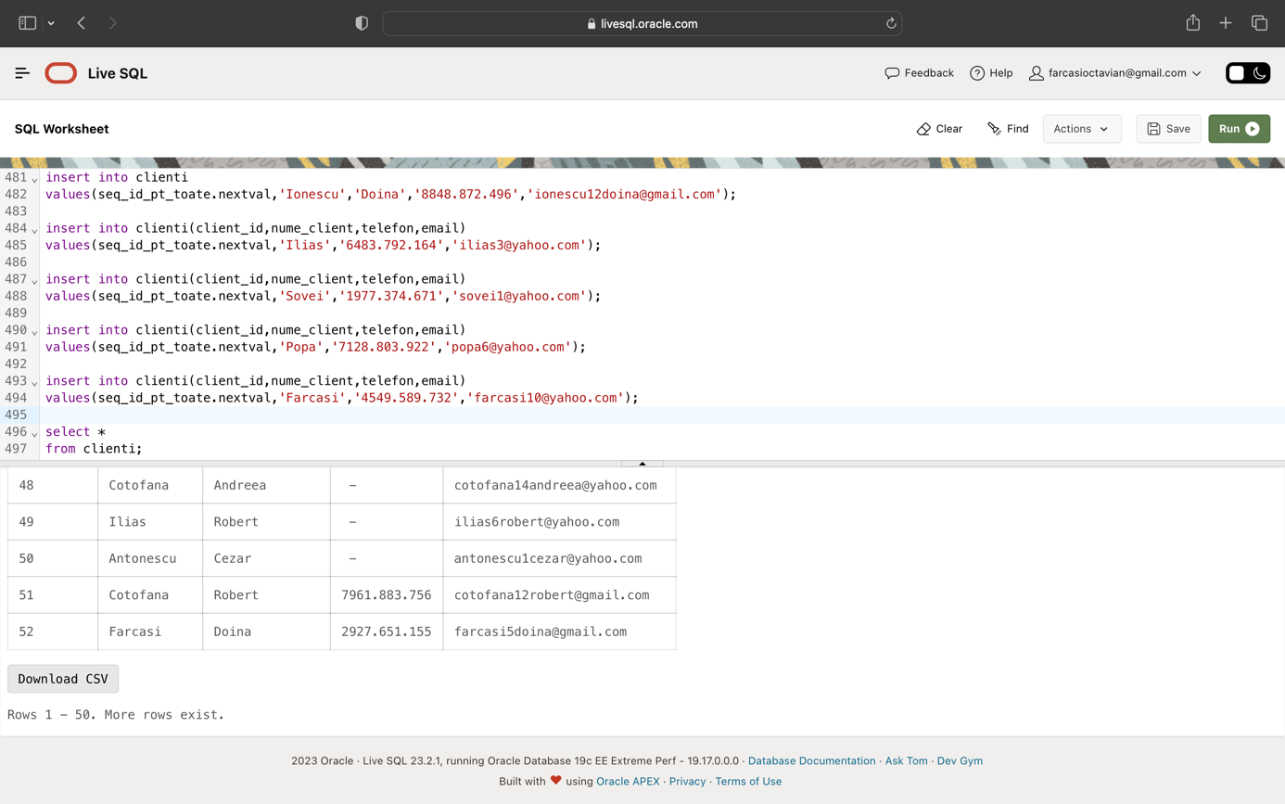

alter sequence seq_id_pt_toate restart;

insert into snacks_uri

values(seq_id_pt_toate.nextval,'Chio Chips',10

);

insert into snacks_uri

values(seq_id_pt_toate.nextval,'Lays Chips',14.50

);

insert into snacks_uri

values(seq_id_pt_toate.nextval,'Doritos Sweet Chilli',12.5

);

insert into snacks_uri

values(seq_id_pt_toate.nextval,'Popcorn sare',20

);

insert into snacks_uri

values(seq_id_pt_toate.nextval,'Popcorn caramel',25

);

insert into snacks_uri

values(seq_id_pt_toate.nextval,'Apa',5

);

insert into snacks_uri

values(seq_id_pt_toate.nextval,'Pepsi',10

);

insert into snacks_uri

values(seq_id_pt_toate.nextval,'Fanta',10

);

insert into snacks_uri

values(seq_id_pt_toate.nextval,'Fuze Tea',10

);

insert into snacks_uri

values(seq_id_pt_toate.nextval,'Sprite',10);

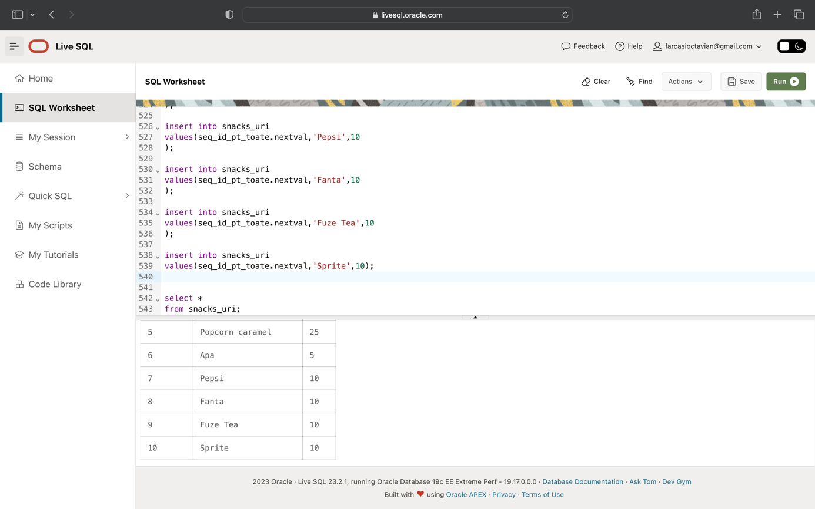

alter sequence seq_id_pt_toate restart;

insert into tranzactii(client_id, snack_id)

values(50,10);

insert into tranzactii(client_id, snack_id)

values(20,8);

insert into tranzactii(client_id, snack_id)

values(19,8);

insert into tranzactii(client_id, snack_id)

values(23,3);

insert into tranzactii(client_id, snack_id)

values(36,5);

insert into tranzactii(client_id, snack_id)

values(17,3);

insert into tranzactii(client_id, snack_id)

values(36,7);

insert into tranzactii(client_id, snack_id)

values(46,1);

insert into tranzactii(client_id, snack_id)

values(28,4);

insert into tranzactii(client_id, snack_id)

values(53,9);

insert into tranzactii(client_id, snack_id)

values(38,1);

insert into tranzactii(client_id, snack_id)

values(56,1);

insert into tranzactii(client_id, snack_id)

values(46,7);

insert into tranzactii(client_id, snack_id)

values(24,2);

insert into tranzactii(client_id, snack_id)

values(52,9);

insert into tranzactii(client_id, snack_id)

values(51,7);

insert into tranzactii(client_id, snack_id)

values(10,8);

insert into tranzactii(client_id, snack_id)

values(40,5);

insert into tranzactii(client_id, snack_id)

values(54,8);

insert into tranzactii(client_id, snack_id)

values(3,9);

insert into tranzactii(client_id, snack_id)

values(30,3);

insert into tranzactii(client_id, snack_id)

values(46,9);

insert into tranzactii(client_id, snack_id)

values(48,1);

insert into tranzactii(client_id, snack_id)

values(48,3);

insert into tranzactii(client_id, snack_id)

values(16,8);

insert into tranzactii

values(37,7,to_date(sysdate-5,'dd-mm-yyyy'));

insert into tranzactii

values(57,5,to_date(sysdate-5,'dd-mm-yyyy'));

insert into tranzactii

values(45,8,to_date(sysdate-5,'dd-mm-yyyy'));

insert into tranzactii

values(33,5,to_date(sysdate-5,'dd-mm-yyyy'));

insert into tranzactii

values(29,3,to_date(sysdate-5,'dd-mm-yyyy'));

insert into tranzactii

values(19,5,to_date(sysdate-5,'dd-mm-yyyy'));

insert into tranzactii

values(47,4,to_date(sysdate-5,'dd-mm-yyyy'));

insert into tranzactii

values(38,8,to_date(sysdate-5,'dd-mm-yyyy'));

insert into tranzactii

values(29,7,to_date(sysdate-5,'dd-mm-yyyy'));

insert into tranzactii

values(5,6,to_date(sysdate-5,'dd-mm-yyyy'));

insert into tranzactii

values(15,3,to_date(sysdate-5,'dd-mm-yyyy'));

insert into tranzactii

values(15,10,to_date(sysdate-5,'dd-mm-yyyy'));

insert into tranzactii

values(55,4,to_date(sysdate-5,'dd-mm-yyyy'));

insert into tranzactii

values(55,7,to_date(sysdate-5,'dd-mm-yyyy'));

insert into tranzactii

values(2,10,to_date(sysdate-5,'dd-mm-yyyy'));

insert into tranzactii

values(31,10,to_date(sysdate-10,'dd-mm-yyyy'));

insert into tranzactii

values(45,4,to_date(sysdate-10,'dd-mm-yyyy'));

insert into tranzactii

values(4,2,to_date(sysdate-10,'dd-mm-yyyy'));

insert into tranzactii

values(43,6,to_date(sysdate-10,'dd-mm-yyyy'));

insert into tranzactii

values(35,2,to_date(sysdate-10,'dd-mm-yyyy'));

insert into tranzactii

values(9,9,to_date(sysdate-10,'dd-mm-yyyy'));

insert into tranzactii

values(4,8,to_date(sysdate-10,'dd-mm-yyyy'));

insert into tranzactii

values(35,10,to_date(sysdate-10,'dd-mm-yyyy'));

insert into tranzactii

values(43,8,to_date(sysdate-10,'dd-mm-yyyy'));

insert into tranzactii

values(23,1,to_date(sysdate-10,'dd-mm-yyyy'));

insert into tranzactii

values(53,6,to_date(sysdate-10,'dd-mm-yyyy'));

insert into tranzactii

values(19,4,to_date(sysdate-10,'dd-mm-yyyy'));

insert into tranzactii

values(10,9,to_date(sysdate-10,'dd-mm-yyyy'));

insert into tranzactii

values(53,4,to_date(sysdate-10,'dd-mm-yyyy'));

insert into tranzactii

values(53,1,to_date(sysdate-10,'dd-mm-yyyy'));

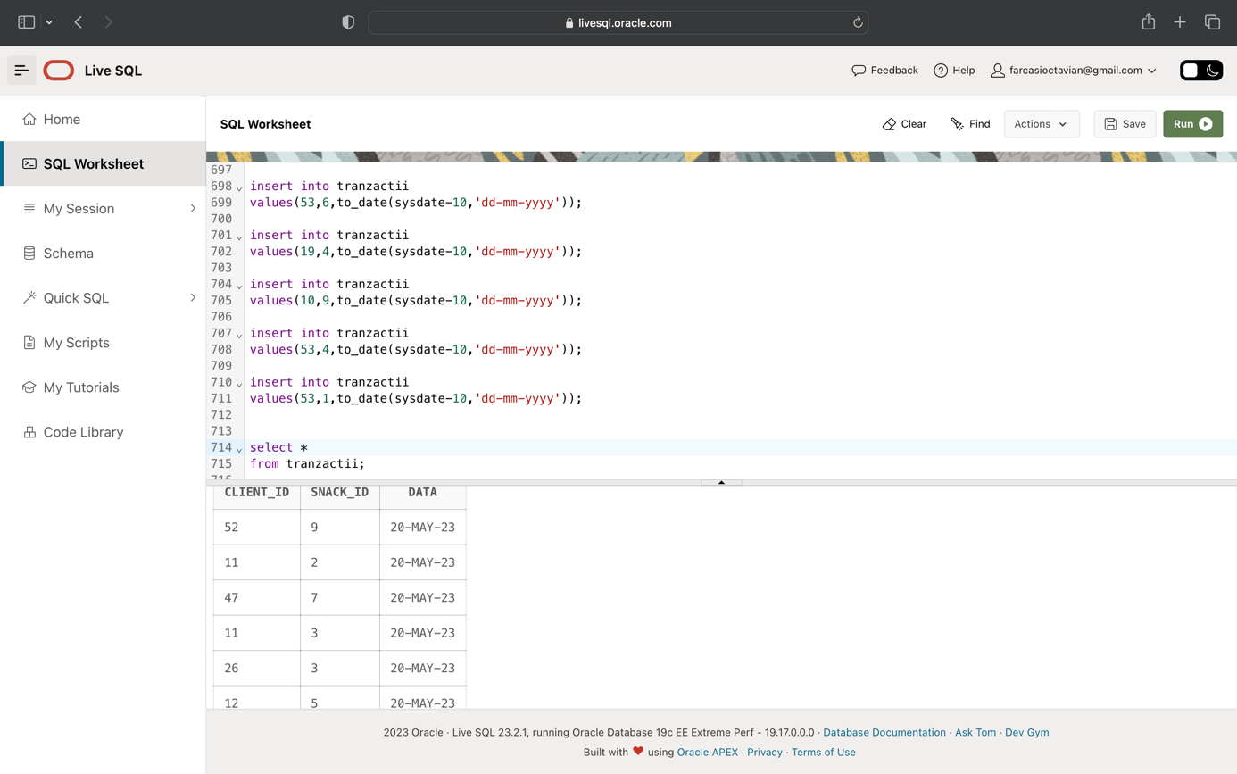

alter sequence seq_id_pt_toate restart;

insert into sectiuni_lucru

values(seq_id_pt_toate.nextval,'Casierie');

insert into sectiuni_lucru

values(seq_id_pt_toate.nextval,'Paza');

insert into sectiuni_lucru

values(seq_id_pt_toate.nextval,'Curatenie_Sali');

insert into sectiuni_lucru

values(seq_id_pt_toate.nextval,'Curatenie_grupuri_sanitare');

insert into sectiuni_lucru

values(seq_id_pt_toate.nextval,'Verificare_bilete');

insert into sectiuni_lucru

values(seq_id_pt_toate.nextval,'Difuzare_film');

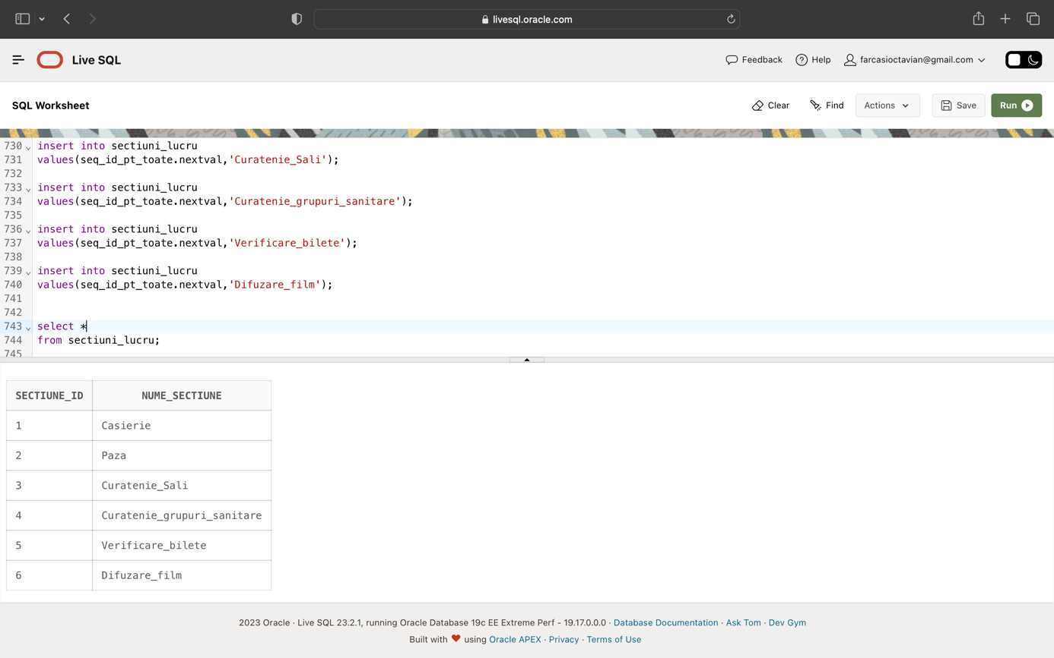

alter sequence seq_id_pt_toate restart;

insert into locatii

values(seq_id_pt_toate.nextval,'Bd_ul. Unirii','Buzau','Buzau');

insert into locatii

values(seq_id_pt_toate.nextval,'Str. Stefan cel Mare','Satu Nou','Vaslui');

insert into locatii

values(seq_id_pt_toate.nextval,'Bd_ul Republicii','Manasia','Urziceni');

insert into locatii

values(seq_id_pt_toate.nextval,'Str. Careiului 77','Ambud','Satu Mare');

insert into locatii

values(seq_id_pt_toate.nextval,'Str. Kis','Rimetea','Alba Iulia');

insert into locatii

values(seq_id_pt_toate.nextval,'Bd_ul. Eroilor 51','Sub Coasta','Cluj_Napoca');

insert into locatii

values(seq_id_pt_toate.nextval,'Str. Energiticianului.','Adancata','Suceava');

insert into locatii

values(seq_id_pt_toate.nextval,'Str. Cuza Voda 102','Municipiul Oltenita','Calarasi');

insert into locatii

values(seq_id_pt_toate.nextval,'Str. Grind','Urechesti','Targu Jiu');

insert into locatii

values(seq_id_pt_toate.nextval,'Calea Vacaresti','Sector 4','Bucuresti');

insert into locatii

values(seq_id_pt_toate.nextval,'Str. Justitiei','Sura Mica','Sibiu');

insert into locatii

values(seq_id_pt_toate.nextval,'Str. Sibiului 5','Poplaca','Sibiu');

insert into locatii

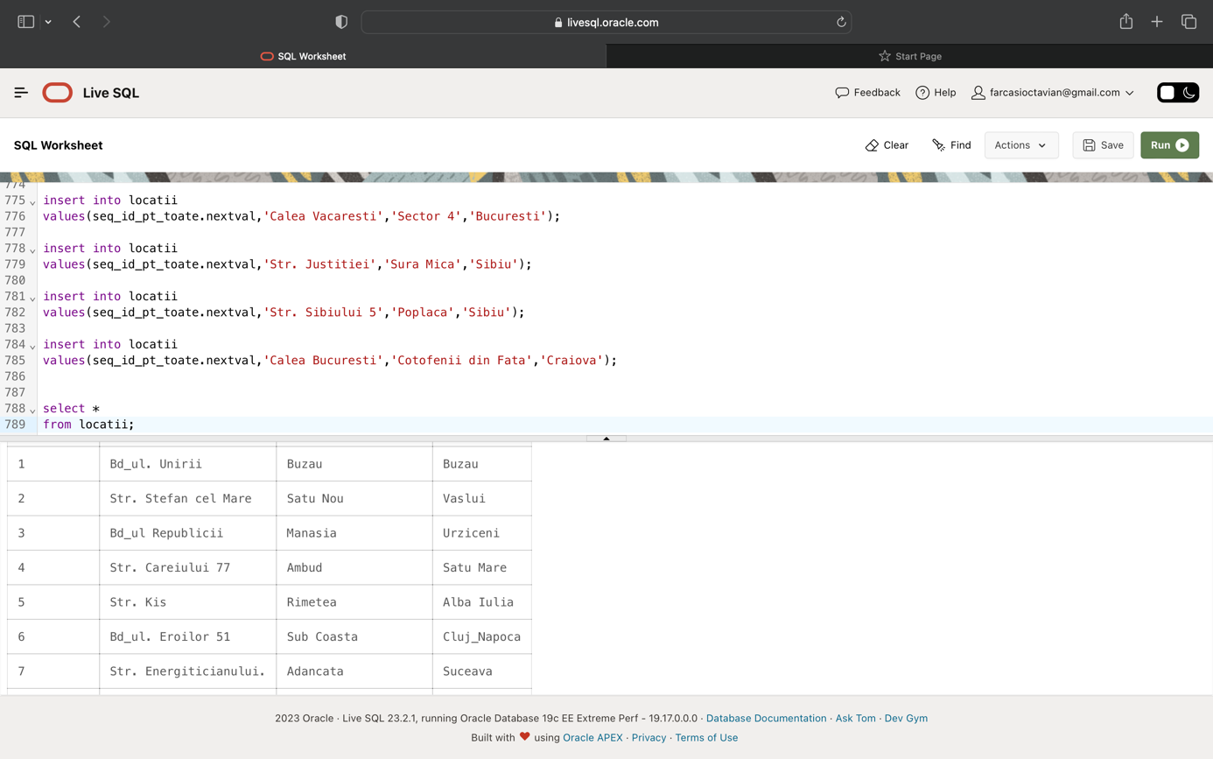values(seq_id_pt_toate.nextval,'Calea Bucuresti','Cotofenii din Fata','Craiova');

alter sequence seq_id_pt_toate restart;

insert into cinematografe

values(seq_id_pt_toate.nextval,13,7);

insert into cinematografe

values(seq_id_pt_toate.nextval,12,16);

insert into cinematografe

values(seq_id_pt_toate.nextval,11,24);

insert into cinematografe

values(seq_id_pt_toate.nextval,10,3);

insert into cinematografe

values(seq_id_pt_toate.nextval,9,3);

insert into cinematografe

values(seq_id_pt_toate.nextval,8,18);

insert into cinematografe

values(seq_id_pt_toate.nextval,7,19);

insert into cinematografe

values(seq_id_pt_toate.nextval,6,6);

insert into cinematografe

values(seq_id_pt_toate.nextval,5,3);

insert into cinematografe

values(seq_id_pt_toate.nextval,4,21);

insert into cinematografe

values(seq_id_pt_toate.nextval,3,10);

insert into cinematografe

values(seq_id_pt_toate.nextval,2,18);

insert into cinematografe

values(seq_id_pt_toate.nextval,1,19);

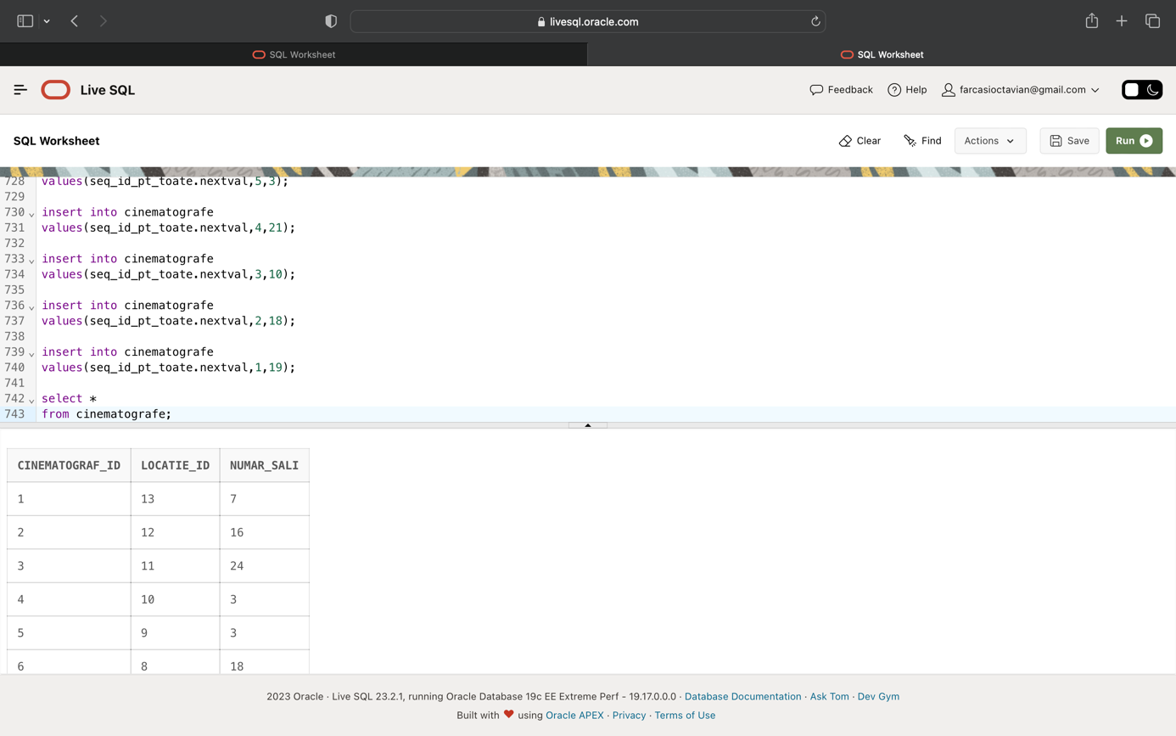

alter sequence seq_id_pt_toate restart;

insert into ture_angajati(tura_id,cinematograf_id,durata)

values(seq_id_pt_toate.nextval,1,8);

insert into ture_angajati(tura_id,cinematograf_id,durata)

values(seq_id_pt_toate.nextval,1,5);

insert into ture_angajati(tura_id,cinematograf_id,durata)

values(seq_id_pt_toate.nextval,2,5);

insert into ture_angajati(tura_id,cinematograf_id,durata)

values(seq_id_pt_toate.nextval,2,7);

insert into ture_angajati(tura_id,cinematograf_id,durata)

values(seq_id_pt_toate.nextval,3,7);

insert into ture_angajati(tura_id,cinematograf_id,durata)

values(seq_id_pt_toate.nextval,3,8);

insert into ture_angajati(tura_id,cinematograf_id,durata)

values(seq_id_pt_toate.nextval,4,5);

insert into ture_angajati(tura_id,cinematograf_id,durata)

values(seq_id_pt_toate.nextval,4,4);

insert into ture_angajati(tura_id,cinematograf_id,durata)

values(seq_id_pt_toate.nextval,5,8);

insert into ture_angajati(tura_id,cinematograf_id,durata)

values(seq_id_pt_toate.nextval,5,5);

insert into ture_angajati(tura_id,cinematograf_id,durata)

values(seq_id_pt_toate.nextval,6,4);

insert into ture_angajati(tura_id,cinematograf_id,durata)

values(seq_id_pt_toate.nextval,6,8);

insert into ture_angajati(tura_id,cinematograf_id,durata)

values(seq_id_pt_toate.nextval,7,5);

insert into ture_angajati(tura_id,cinematograf_id,durata)

values(seq_id_pt_toate.nextval,7,7);

insert into ture_angajati(tura_id,cinematograf_id,durata)

values(seq_id_pt_toate.nextval,8,5);

insert into ture_angajati(tura_id,cinematograf_id,durata)

values(seq_id_pt_toate.nextval,8,7);

insert into ture_angajati(tura_id,cinematograf_id,durata)

values(seq_id_pt_toate.nextval,9,7);

insert into ture_angajati(tura_id,cinematograf_id,durata)

values(seq_id_pt_toate.nextval,9,8);

insert into ture_angajati(tura_id,cinematograf_id,durata)

values(seq_id_pt_toate.nextval,10,5);

insert into ture_angajati(tura_id,cinematograf_id,durata)

values(seq_id_pt_toate.nextval,10,7);

insert into ture_angajati(tura_id,cinematograf_id,durata)

values(seq_id_pt_toate.nextval,11,4);

insert into ture_angajati(tura_id,cinematograf_id,durata)

values(seq_id_pt_toate.nextval,11,6);

insert into ture_angajati(tura_id,cinematograf_id,durata)

values(seq_id_pt_toate.nextval,12,8);

insert into ture_angajati(tura_id,cinematograf_id,durata)

values(seq_id_pt_toate.nextval,12,7);

insert into ture_angajati(tura_id,cinematograf_id,durata)

values(seq_id_pt_toate.nextval,13,8);

insert into ture_angajati(tura_id,cinematograf_id,durata)

values(seq_id_pt_toate.nextval,13,4);

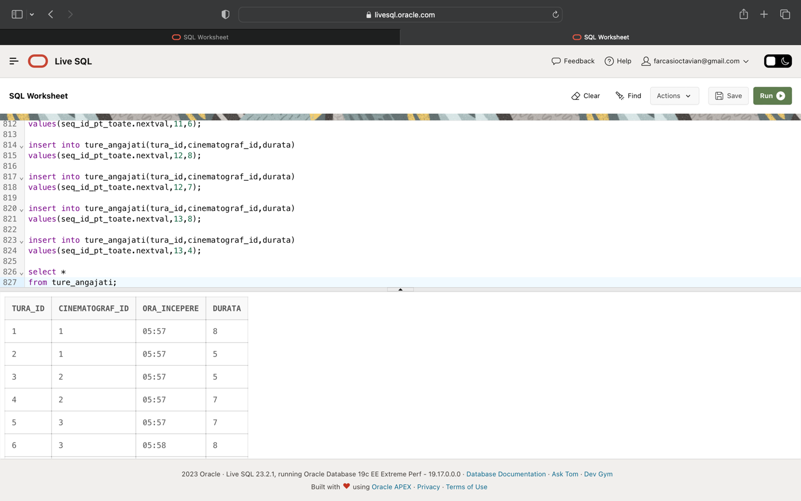

alter sequence seq_id_pt_toate restart;

insert into angajati

values(seq_id_pt_toate.nextval,1,1,'Anghel','Teodor',2000,'7212.178.483');

insert into angajati

values(seq_id_pt_toate.nextval,2,1,'Radaut','Flavia',1500,'5750.934.570');

insert into angajati

values(seq_id_pt_toate.nextval,3,1,'Farcasi','Andrei',2000,'4322.109.555');

insert into angajati

values(seq_id_pt_toate.nextval,4,1,'Ionescu','Medeea',2900,'1608.114.979');

insert into angajati

values(seq_id_pt_toate.nextval,5,1,'Serban','Andrei',1800,'9720.945.934');

insert into angajati

values(seq_id_pt_toate.nextval,6,1,'Stefanescu','Jamila',2200,'6562.865.786');

insert into angajati

values(seq_id_pt_toate.nextval,3,2,'Culinaru','Violeta',1900,'8810.917.762');

insert into angajati

values(seq_id_pt_toate.nextval,1,3,'Cormoran','Matei',1500,'8079.867.514');

insert into angajati

values(seq_id_pt_toate.nextval,2,3,'Ionescu','Andreea',1900,'5731.181.137');

insert into angajati

values(seq_id_pt_toate.nextval,3,3,'Culinaru','Andrei',1800,'6945.574.196');

insert into angajati

values(seq_id_pt_toate.nextval,4,3,'Ionescu','Alexia',1900,'6453.765.833');

insert into angajati

values(seq_id_pt_toate.nextval,5,3,'Farcasi','Flavia',3000,'3535.845.507');

insert into angajati

values(seq_id_pt_toate.nextval,6,3,'Ilias','Valentin',2500,'3622.645.856');

insert into angajati

values(seq_id_pt_toate.nextval,1,4,'Moraru','Aza',1900,'1747.624.811');

insert into angajati

values(seq_id_pt_toate.nextval,1,5,'Stefanescu','Luciana',2400,'8067.602.742');

insert into angajati

values(seq_id_pt_toate.nextval,2,5,'Moraru','Ion',2200,'5010.395.804');

insert into angajati

values(seq_id_pt_toate.nextval,3,5,'Popescu','Andreea',1900,'1624.910.859');

insert into angajati

values(seq_id_pt_toate.nextval,4,5,'Vladileanu','Daniel',2500,'8139.311.962');

insert into angajati

values(seq_id_pt_toate.nextval,5,5,'Popescu','Aza',1500,'7567.943.267');

insert into angajati

values(seq_id_pt_toate.nextval,6,5,'Cuza','Andreea',2400,'9410.496.972');

insert into angajati

values(seq_id_pt_toate.nextval,6,6,'Radaut','Marius',1900,'7368.980.524');

insert into angajati

values(seq_id_pt_toate.nextval,1,7,'Dascalu','Alexia',2200,'8976.580.387');

insert into angajati

values(seq_id_pt_toate.nextval,2,7,'Antonescu','Alexia',2500,'7714.818.758');

insert into angajati

values(seq_id_pt_toate.nextval,3,7,'Dumitru','Matei',2300,'7882.180.420');

insert into angajati

values(seq_id_pt_toate.nextval,4,7,'Antonescu','Robert',2800,'6741.815.573');

insert into angajati

values(seq_id_pt_toate.nextval,5,7,'Dascalu','Violeta',3000,'2180.439.398');

insert into angajati

values(seq_id_pt_toate.nextval,6,7,'Stoica','Ion',2400,'1625.525.140');

insert into angajati

values(seq_id_pt_toate.nextval,4,8,'Ionescu','Medeea',2100,'6756.401.619');

insert into angajati

values(seq_id_pt_toate.nextval,1,9,'Ionescu','Maria',2300,'8333.342.346');

insert into angajati

values(seq_id_pt_toate.nextval,2,9,'Dascalu','Marius',2000,'1322.892.470');

insert into angajati

values(seq_id_pt_toate.nextval,3,9,'Dascalu','Violeta',1800,'4958.422.480');

insert into angajati

values(seq_id_pt_toate.nextval,4,9,'Cotofana','Jamila',1600,'6229.263.689');

insert into angajati

values(seq_id_pt_toate.nextval,5,9,'Ilias','Jamila',2200,'9553.833.286');

insert into angajati

values(seq_id_pt_toate.nextval,6,9,'Antonescu','Maria',3000,'8842.304.606');

insert into angajati

values(seq_id_pt_toate.nextval,1,10,'Stoica','Aza',2400,'6576.542.194');

insert into angajati

values(seq_id_pt_toate.nextval,1,11,'Popescu','Valentin',2500,'3288.449.468');

insert into angajati

values(seq_id_pt_toate.nextval,2,11,'Radaut','Andrei',2100,'9354.439.518');

insert into angajati

values(seq_id_pt_toate.nextval,3,11,'Cuza','Daniel',1600,'4722.173.934');

insert into angajati

values(seq_id_pt_toate.nextval,4,11,'Cotofana','Medeea',2600,'9103.520.598');

insert into angajati

values(seq_id_pt_toate.nextval,5,11,'Anghel','Violeta',2600,'5495.321.265');

insert into angajati

values(seq_id_pt_toate.nextval,6,11,'Radaut','Valentin',2500,'2403.359.246');

insert into angajati

values(seq_id_pt_toate.nextval,5,12,'Stoica','Cristian',1600,'2291.599.739');

insert into angajati

values(seq_id_pt_toate.nextval,1,13,'Cotofana','Bogdan',2500,'9242.449.421');

insert into angajati

values(seq_id_pt_toate.nextval,2,13,'Cormoran','Ion',2600,'9796.338.668');

insert into angajati

values(seq_id_pt_toate.nextval,3,13,'Chifoi','Teodor',2400,'5499.595.871');

insert into angajati

values(seq_id_pt_toate.nextval,4,13,'Mircea','Doina',1900,'5363.552.805');

insert into angajati

values(seq_id_pt_toate.nextval,5,13,'Farcasi','Doina',1900,'4870.706.317');

insert into angajati

values(seq_id_pt_toate.nextval,6,13,'Stefanescu','Matei',1800,'6297.916.219');

insert into angajati

values(seq_id_pt_toate.nextval,4,14,'Serban','Maria',2900,'3273.248.904');

insert into angajati

values(seq_id_pt_toate.nextval,1,15,'Culinaru','Teodor',2300,'6873.512.831');

insert into angajati

values(seq_id_pt_toate.nextval,2,15,'Serban','Luciana',2000,'7315.788.906');

insert into angajati

values(seq_id_pt_toate.nextval,3,15,'Farcasi','Luciana',2500,'2015.526.592');

insert into angajati

values(seq_id_pt_toate.nextval,4,15,'Cormoran','Andrei',2900,'1394.672.498');

insert into angajati

values(seq_id_pt_toate.nextval,5,15,'Culinaru','Teodor',2100,'2121.452.908');

insert into angajati

values(seq_id_pt_toate.nextval,6,15,'Chifoi','Robert',3000,'5656.811.529');

insert into angajati

values(seq_id_pt_toate.nextval,3,16,'Antonescu','Cosmin',2800,'7970.635.937');

insert into angajati

values(seq_id_pt_toate.nextval,1,17,'Popescu','Jamila',2200,'9393.178.841');

insert into angajati

values(seq_id_pt_toate.nextval,2,17,'Chifoi','Violeta',3000,'3925.326.105');

insert into angajati

values(seq_id_pt_toate.nextval,3,17,'Popa','Alexia',2500,'5704.978.869');

insert into angajati

values(seq_id_pt_toate.nextval,4,17,'Popescu','Violeta',3000,'6998.340.995');

insert into angajati

values(seq_id_pt_toate.nextval,5,17,'Ionescu','Ion',2600,'8332.407.787');

insert into angajati

values(seq_id_pt_toate.nextval,6,17,'Ilias','Jamila',2100,'7944.650.478');

insert into angajati

values(seq_id_pt_toate.nextval,4,18,'Sovei','Matei',1500,'7332.984.283');

insert into angajati

values(seq_id_pt_toate.nextval,1,19,'Stefanescu','Cristian',2000,'1491.310.568');

insert into angajati

values(seq_id_pt_toate.nextval,2,19,'Popescu','Valentin',2900,'7060.723.934');

insert into angajati

values(seq_id_pt_toate.nextval,3,19,'Ghergu','Flavia',1800,'3768.784.859');

insert into angajati

values(seq_id_pt_toate.nextval,4,19,'Stefanescu','Flavia',2200,'3802.825.790');

insert into angajati

values(seq_id_pt_toate.nextval,5,19,'Ionescu','Aza',2100,'1757.570.411');

insert into angajati

values(seq_id_pt_toate.nextval,6,19,'Sovei','Daniel',2300,'8490.144.481');

insert into angajati

values(seq_id_pt_toate.nextval,4,20,'Serban','Cezar',2600,'5177.703.188');

insert into angajati

values(seq_id_pt_toate.nextval,1,21,'Culinaru','Teodor',2100,'7018.937.925');

insert into angajati

values(seq_id_pt_toate.nextval,2,21,'Cuza','Doina',2500,'3945.216.565');

insert into angajati

values(seq_id_pt_toate.nextval,3,21,'Dascalu','Daniel',2600,'2186.874.213');

insert into angajati

values(seq_id_pt_toate.nextval,4,21,'Ghergu','Catalin',1900,'2683.383.608');

insert into angajati

values(seq_id_pt_toate.nextval,5,21,'Farcasi','Cristian',2500,'2611.664.250');

insert into angajati

values(seq_id_pt_toate.nextval,6,21,'Culinaru','Doina',1600,'7680.494.555');

insert into angajati

values(seq_id_pt_toate.nextval,1,22,'Chifoi','Luciana',2400,'2543.801.952');

insert into angajati

values(seq_id_pt_toate.nextval,1,23,'Sovei','Alexia',2100,'9767.102.969');

insert into angajati

values(seq_id_pt_toate.nextval,2,23,'Chifoi','Andrei',1500,'2136.575.977');

insert into angajati

values(seq_id_pt_toate.nextval,3,23,'Cotofana','Robert',1900,'1584.973.715');

insert into angajati

values(seq_id_pt_toate.nextval,4,23,'Dascalu','Bogdan',1800,'3955.835.165');

insert into angajati

values(seq_id_pt_toate.nextval,5,23,'Culinaru','Daniel',2300,'5393.900.154');

insert into angajati

values(seq_id_pt_toate.nextval,6,23,'Anghel','Bogdan',1800,'2914.945.847');

insert into angajati

values(seq_id_pt_toate.nextval,5,24,'Radaut','Cosmin',1500,'2363.726.467');

insert into angajati

values(seq_id_pt_toate.nextval,1,25,'Culinaru','Cristian',2900,'4529.848.778');

insert into angajati

values(seq_id_pt_toate.nextval,2,25,'Vladileanu','Teodor',2800,'6212.806.471');

insert into angajati

values(seq_id_pt_toate.nextval,3,25,'Chifoi','Ion',1800,'1669.306.353');

insert into angajati

values(seq_id_pt_toate.nextval,4,25,'Ionescu','Flavia',2800,'9568.878.393');

insert into angajati

values(seq_id_pt_toate.nextval,5,25,'Cotofana','Andrei',2500,'4549.877.261');

insert into angajati

values(seq_id_pt_toate.nextval,6,25,'Stefanescu','Valentin',2500,'4963.188.966');

insert into angajati

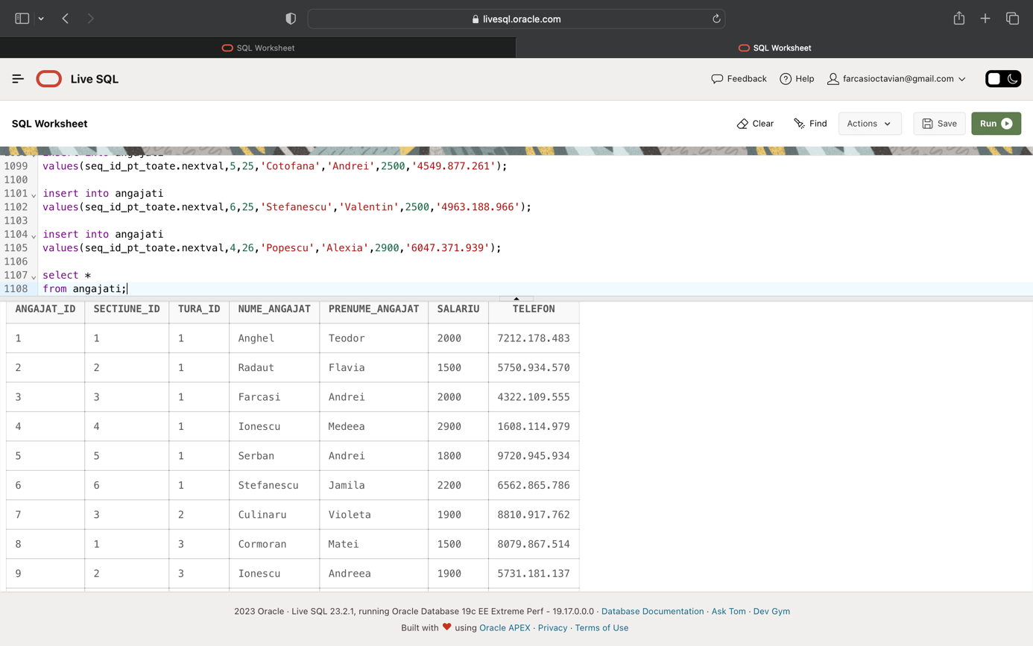values(seq_id_pt_toate.nextval,4,26,'Popescu','Alexia',2900,'6047.371.939');

alter sequence seq_id_pt_toate restart;

insert into sali_cinematograf

values(seq_id_pt_toate.nextval,1,20);

insert into sali_cinematograf

values(seq_id_pt_toate.nextval,1,82);

insert into sali_cinematograf

values(seq_id_pt_toate.nextval,2,22);

insert into sali_cinematograf

values(seq_id_pt_toate.nextval,3,43);

insert into sali_cinematograf

values(seq_id_pt_toate.nextval,3,38);

insert into sali_cinematograf

values(seq_id_pt_toate.nextval,3,52);

insert into sali_cinematograf

values(seq_id_pt_toate.nextval,4,54);

insert into sali_cinematograf

values(seq_id_pt_toate.nextval,4,84);

insert into sali_cinematograf

values(seq_id_pt_toate.nextval,4,52);

insert into sali_cinematograf

values(seq_id_pt_toate.nextval,5,46);

insert into sali_cinematograf

values(seq_id_pt_toate.nextval,6,22);

insert into sali_cinematograf

values(seq_id_pt_toate.nextval,7,91);

insert into sali_cinematograf

values(seq_id_pt_toate.nextval,7,27);

insert into sali_cinematograf

values(seq_id_pt_toate.nextval,8,52);

insert into sali_cinematograf

values(seq_id_pt_toate.nextval,8,76);

insert into sali_cinematograf

values(seq_id_pt_toate.nextval,8,85);

insert into sali_cinematograf

values(seq_id_pt_toate.nextval,8,90);

insert into sali_cinematograf

values(seq_id_pt_toate.nextval,9,93);

insert into sali_cinematograf

values(seq_id_pt_toate.nextval,9,84);

insert into sali_cinematograf

values(seq_id_pt_toate.nextval,9,76);

insert into sali_cinematograf

values(seq_id_pt_toate.nextval,10,55);

insert into sali_cinematograf

values(seq_id_pt_toate.nextval,10,70);

insert into sali_cinematograf

values(seq_id_pt_toate.nextval,11,88);

insert into sali_cinematograf

values(seq_id_pt_toate.nextval,12,30);

insert into sali_cinematograf

values(seq_id_pt_toate.nextval,13,45);

insert into sali_cinematograf

values(seq_id_pt_toate.nextval,13,49);

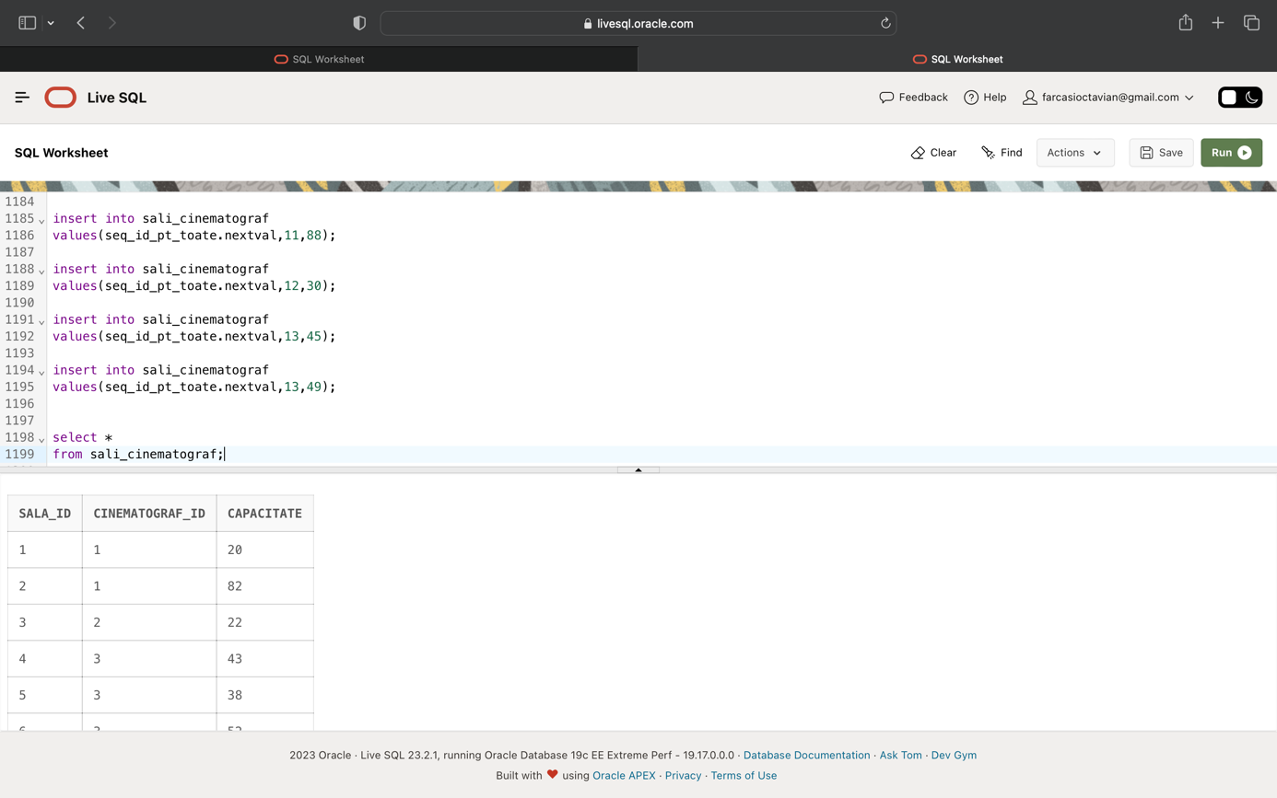

alter sequence seq_id_pt_toate restart;

insert into transmiteri

values(seq_id_pt_toate.nextval,7,9,'28-04-2023,15:00',59);

insert into transmiteri

values(seq_id_pt_toate.nextval,11,13,'29-05-2023,14:30',12);

insert into transmiteri

values(seq_id_pt_toate.nextval,2,16,'29-04-2023,17:00',84);

insert into transmiteri

values(seq_id_pt_toate.nextval,11,5,'13-07-2023,18:50',22);

insert into transmiteri

values(seq_id_pt_toate.nextval,10,10,'23-08-2023,20:50',66);

insert into transmiteri

values(seq_id_pt_toate.nextval,3,21,'10-09-2023,24:50',81);

insert into transmiteri

values(seq_id_pt_toate.nextval,2,1,'14-08-2023,17:10',44);

insert into transmiteri

values(seq_id_pt_toate.nextval,3,19,'21-08-2023,17:40',71);

insert into transmiteri

values(seq_id_pt_toate.nextval,13,24,'21-08-2023,18:30',19);

insert into transmiteri

values(seq_id_pt_toate.nextval,3,11,'19-03-2023,14:30',30);

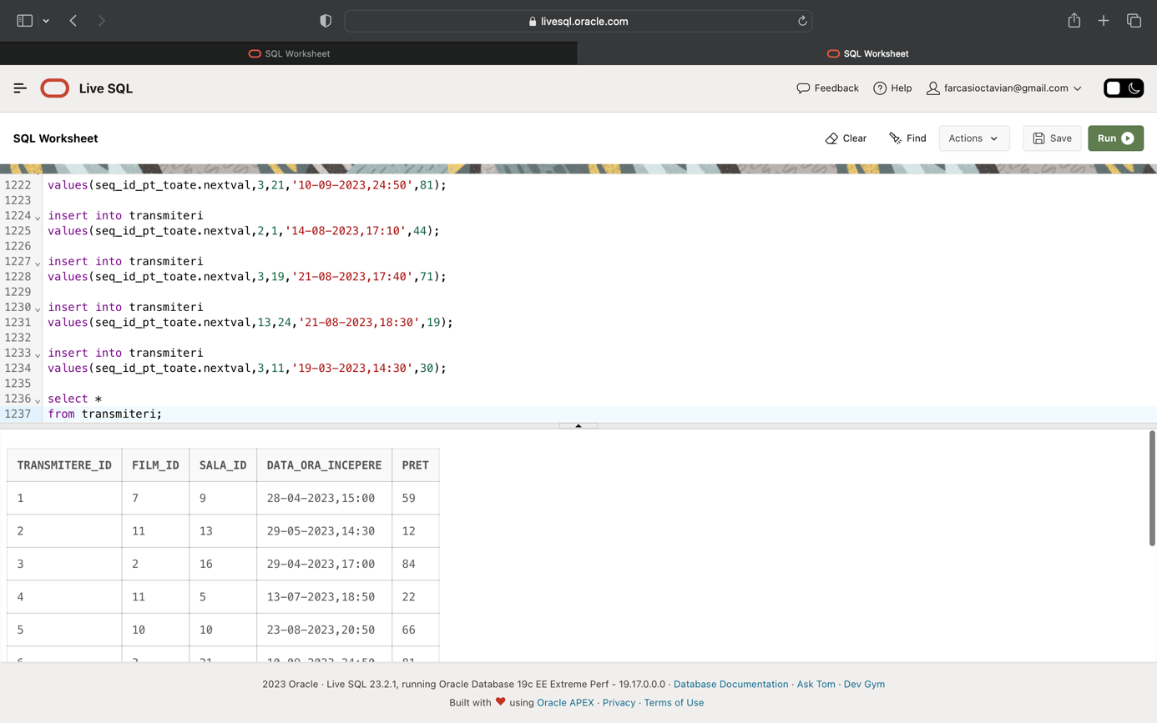

alter sequence seq_id_pt_toate restart;

insert into locuri_sala

values(seq_id_pt_toate.nextval,1,'f',10);

insert into locuri_sala

values(seq_id_pt_toate.nextval,1,'i',9);

insert into locuri_sala

values(seq_id_pt_toate.nextval,1,'e',1);

insert into locuri_sala

values(seq_id_pt_toate.nextval,1,'b',1);

insert into locuri_sala

values(seq_id_pt_toate.nextval,1,'n',5);

insert into locuri_sala

values(seq_id_pt_toate.nextval,1,'p',3);

insert into locuri_sala

values(seq_id_pt_toate.nextval,1,'i',7);

insert into locuri_sala

values(seq_id_pt_toate.nextval,1,'w',2);

insert into locuri_sala

values(seq_id_pt_toate.nextval,1,'e',4);

insert into locuri_sala

values(seq_id_pt_toate.nextval,2,'j',13);

insert into locuri_sala

values(seq_id_pt_toate.nextval,2,'t',18);

insert into locuri_sala

values(seq_id_pt_toate.nextval,2,'h',23);

insert into locuri_sala

values(seq_id_pt_toate.nextval,2,'x',16);

insert into locuri_sala

values(seq_id_pt_toate.nextval,2,'r',29);

insert into locuri_sala

values(seq_id_pt_toate.nextval,3,'c',8);

insert into locuri_sala

values(seq_id_pt_toate.nextval,3,'s',2);

insert into locuri_sala

values(seq_id_pt_toate.nextval,3,'r',7);

insert into locuri_sala

values(seq_id_pt_toate.nextval,3,'q',7);

insert into locuri_sala

values(seq_id_pt_toate.nextval,3,'l',3);

insert into locuri_sala

values(seq_id_pt_toate.nextval,3,'y',8);

insert into locuri_sala

values(seq_id_pt_toate.nextval,3,'r',4);

insert into locuri_sala

values(seq_id_pt_toate.nextval,3,'s',11);

insert into locuri_sala

values(seq_id_pt_toate.nextval,3,'h',4);

insert into locuri_sala

values(seq_id_pt_toate.nextval,4,'b',13);

insert into locuri_sala

values(seq_id_pt_toate.nextval,4,'u',1);

insert into locuri_sala

values(seq_id_pt_toate.nextval,4,'z',9);

insert into locuri_sala

values(seq_id_pt_toate.nextval,4,'k',13);

insert into locuri_sala

values(seq_id_pt_toate.nextval,4,'o',3);

insert into locuri_sala

values(seq_id_pt_toate.nextval,4,'z',4);

insert into locuri_sala

values(seq_id_pt_toate.nextval,4,'t',2);

insert into locuri_sala

values(seq_id_pt_toate.nextval,4,'r',3);

insert into locuri_sala

values(seq_id_pt_toate.nextval,4,'m',9);

insert into locuri_sala

values(seq_id_pt_toate.nextval,5,'b',1);

insert into locuri_sala

values(seq_id_pt_toate.nextval,5,'b',6);

insert into locuri_sala

values(seq_id_pt_toate.nextval,5,'p',7);

insert into locuri_sala

values(seq_id_pt_toate.nextval,5,'j',2);

insert into locuri_sala

values(seq_id_pt_toate.nextval,5,'m',2);

insert into locuri_sala

values(seq_id_pt_toate.nextval,5,'z',2);

insert into locuri_sala

values(seq_id_pt_toate.nextval,5,'m',9);

insert into locuri_sala

values(seq_id_pt_toate.nextval,5,'e',9);

insert into locuri_sala

values(seq_id_pt_toate.nextval,5,'u',19);

insert into locuri_sala

values(seq_id_pt_toate.nextval,6,'o',18);

insert into locuri_sala

values(seq_id_pt_toate.nextval,6,'l',24);

insert into locuri_sala

values(seq_id_pt_toate.nextval,6,'o',8);

insert into locuri_sala

values(seq_id_pt_toate.nextval,6,'i',7);

insert into locuri_sala

values(seq_id_pt_toate.nextval,6,'p',18);

insert into locuri_sala

values(seq_id_pt_toate.nextval,6,'q',6);

insert into locuri_sala

values(seq_id_pt_toate.nextval,6,'q',25);

insert into locuri_sala

values(seq_id_pt_toate.nextval,6,'c',11);

insert into locuri_sala

values(seq_id_pt_toate.nextval,7,'p',25);

insert into locuri_sala

values(seq_id_pt_toate.nextval,7,'i',23);

insert into locuri_sala

values(seq_id_pt_toate.nextval,7,'b',9);

insert into locuri_sala

values(seq_id_pt_toate.nextval,8,'j',15);

insert into locuri_sala

values(seq_id_pt_toate.nextval,8,'r',32);

insert into locuri_sala

values(seq_id_pt_toate.nextval,8,'e',21);

insert into locuri_sala

values(seq_id_pt_toate.nextval,9,'u',22);

insert into locuri_sala

values(seq_id_pt_toate.nextval,9,'j',26);

insert into locuri_sala

values(seq_id_pt_toate.nextval,9,'h',26);

insert into locuri_sala

values(seq_id_pt_toate.nextval,9,'q',12);

insert into locuri_sala

values(seq_id_pt_toate.nextval,9,'a',4);

insert into locuri_sala

values(seq_id_pt_toate.nextval,9,'d',13);

insert into locuri_sala

values(seq_id_pt_toate.nextval,9,'a',7);

insert into locuri_sala

values(seq_id_pt_toate.nextval,9,'h',8);

insert into locuri_sala

values(seq_id_pt_toate.nextval,10,'m',15);

insert into locuri_sala

values(seq_id_pt_toate.nextval,10,'x',12);

insert into locuri_sala

values(seq_id_pt_toate.nextval,10,'q',8);

insert into locuri_sala

values(seq_id_pt_toate.nextval,10,'j',10);

insert into locuri_sala

values(seq_id_pt_toate.nextval,10,'u',22);

insert into locuri_sala

values(seq_id_pt_toate.nextval,11,'m',6);

insert into locuri_sala

values(seq_id_pt_toate.nextval,11,'e',4);

insert into locuri_sala

values(seq_id_pt_toate.nextval,11,'h',10);

insert into locuri_sala

values(seq_id_pt_toate.nextval,11,'t',5);

insert into locuri_sala

values(seq_id_pt_toate.nextval,11,'v',6);

insert into locuri_sala

values(seq_id_pt_toate.nextval,11,'s',1);

insert into locuri_sala

values(seq_id_pt_toate.nextval,11,'g',6);

insert into locuri_sala

values(seq_id_pt_toate.nextval,11,'j',10);

insert into locuri_sala

values(seq_id_pt_toate.nextval,12,'e',1);

insert into locuri_sala

values(seq_id_pt_toate.nextval,12,'t',28);

insert into locuri_sala

values(seq_id_pt_toate.nextval,12,'f',45);

insert into locuri_sala

values(seq_id_pt_toate.nextval,12,'k',17);

insert into locuri_sala

values(seq_id_pt_toate.nextval,12,'j',37);

insert into locuri_sala

values(seq_id_pt_toate.nextval,12,'x',36);

insert into locuri_sala

values(seq_id_pt_toate.nextval,12,'v',7);

insert into locuri_sala

values(seq_id_pt_toate.nextval,12,'g',26);

insert into locuri_sala

values(seq_id_pt_toate.nextval,13,'b',2);

insert into locuri_sala

values(seq_id_pt_toate.nextval,13,'d',2);

insert into locuri_sala

values(seq_id_pt_toate.nextval,13,'w',1);

insert into locuri_sala

values(seq_id_pt_toate.nextval,13,'r',5);

insert into locuri_sala

values(seq_id_pt_toate.nextval,13,'y',4);

insert into locuri_sala

values(seq_id_pt_toate.nextval,13,'q',10);

insert into locuri_sala

values(seq_id_pt_toate.nextval,13,'o',3);

insert into locuri_sala

values(seq_id_pt_toate.nextval,13,'b',4);

insert into locuri_sala

values(seq_id_pt_toate.nextval,13,'q',8);

insert into locuri_sala

values(seq_id_pt_toate.nextval,14,'v',12);

insert into locuri_sala

values(seq_id_pt_toate.nextval,15,'z',26);

insert into locuri_sala

values(seq_id_pt_toate.nextval,15,'j',17);

insert into locuri_sala

values(seq_id_pt_toate.nextval,15,'b',3);

insert into locuri_sala

values(seq_id_pt_toate.nextval,15,'u',25);

insert into locuri_sala

values(seq_id_pt_toate.nextval,15,'y',24);

insert into locuri_sala

values(seq_id_pt_toate.nextval,15,'s',10);

insert into locuri_sala

values(seq_id_pt_toate.nextval,15,'m',35);

insert into locuri_sala

values(seq_id_pt_toate.nextval,15,'d',7);

insert into locuri_sala

values(seq_id_pt_toate.nextval,15,'g',31);

insert into locuri_sala

values(seq_id_pt_toate.nextval,15,'x',36);

insert into locuri_sala

values(seq_id_pt_toate.nextval,16,'e',37);

insert into locuri_sala

values(seq_id_pt_toate.nextval,16,'o',33);

insert into locuri_sala

values(seq_id_pt_toate.nextval,16,'d',24);

insert into locuri_sala

values(seq_id_pt_toate.nextval,16,'w',4);

insert into locuri_sala

values(seq_id_pt_toate.nextval,16,'d',26);

insert into locuri_sala

values(seq_id_pt_toate.nextval,16,'j',37);

insert into locuri_sala

values(seq_id_pt_toate.nextval,17,'p',43);

insert into locuri_sala

values(seq_id_pt_toate.nextval,17,'c',3);

insert into locuri_sala

values(seq_id_pt_toate.nextval,18,'o',34);

insert into locuri_sala

values(seq_id_pt_toate.nextval,18,'w',45);

insert into locuri_sala

values(seq_id_pt_toate.nextval,18,'d',27);

insert into locuri_sala

values(seq_id_pt_toate.nextval,18,'w',39);

insert into locuri_sala

values(seq_id_pt_toate.nextval,18,'p',40);

insert into locuri_sala

values(seq_id_pt_toate.nextval,18,'l',29);

insert into locuri_sala

values(seq_id_pt_toate.nextval,18,'i',29);

insert into locuri_sala

values(seq_id_pt_toate.nextval,19,'x',40);

insert into locuri_sala

values(seq_id_pt_toate.nextval,19,'q',3);

insert into locuri_sala

values(seq_id_pt_toate.nextval,20,'v',24);

insert into locuri_sala

values(seq_id_pt_toate.nextval,20,'z',2);

insert into locuri_sala

values(seq_id_pt_toate.nextval,20,'d',1);

insert into locuri_sala

values(seq_id_pt_toate.nextval,20,'k',22);

insert into locuri_sala

values(seq_id_pt_toate.nextval,20,'d',11);

insert into locuri_sala

values(seq_id_pt_toate.nextval,20,'m',16);

insert into locuri_sala

values(seq_id_pt_toate.nextval,21,'z',18);

insert into locuri_sala

values(seq_id_pt_toate.nextval,21,'t',12);

insert into locuri_sala

values(seq_id_pt_toate.nextval,21,'v',11);

insert into locuri_sala

values(seq_id_pt_toate.nextval,21,'m',27);

insert into locuri_sala

values(seq_id_pt_toate.nextval,21,'q',1);

insert into locuri_sala

values(seq_id_pt_toate.nextval,22,'v',33);

insert into locuri_sala

values(seq_id_pt_toate.nextval,22,'i',31);

insert into locuri_sala

values(seq_id_pt_toate.nextval,23,'b',6);

insert into locuri_sala

values(seq_id_pt_toate.nextval,23,'w',4);

insert into locuri_sala

values(seq_id_pt_toate.nextval,23,'t',39);

insert into locuri_sala

values(seq_id_pt_toate.nextval,23,'c',16);

insert into locuri_sala

values(seq_id_pt_toate.nextval,23,'m',37);

insert into locuri_sala

values(seq_id_pt_toate.nextval,23,'m',42);

insert into locuri_sala

values(seq_id_pt_toate.nextval,23,'t',23);

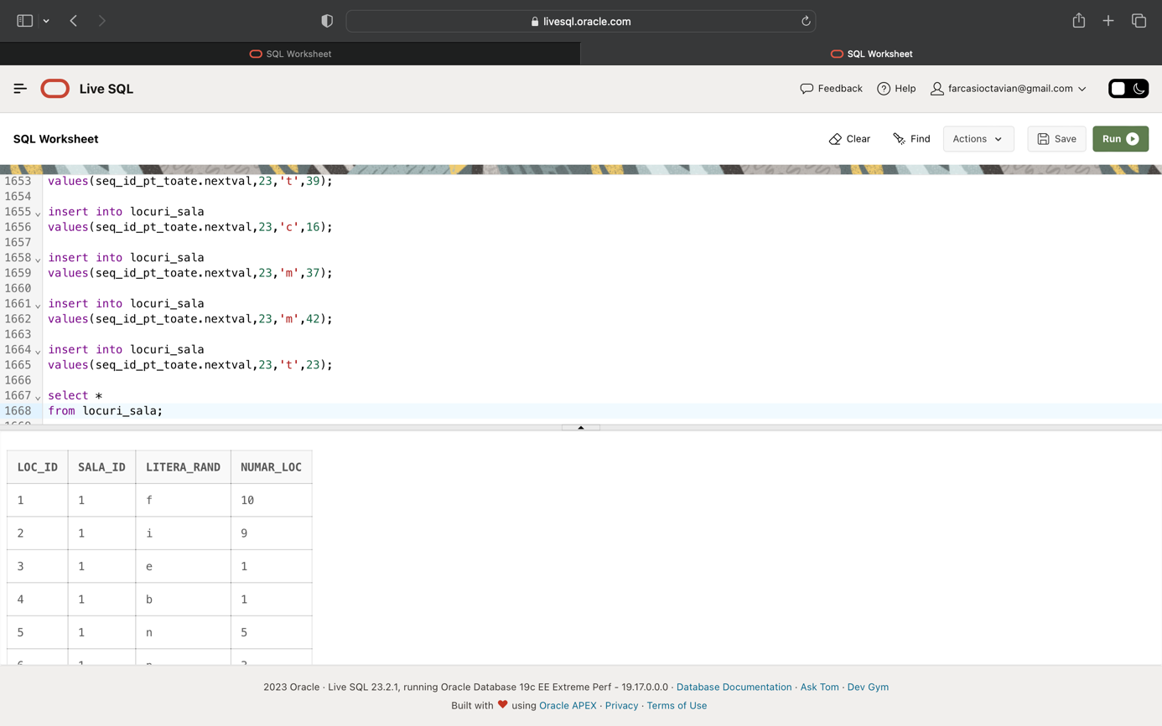

alter sequence seq_id_pt_toate restart;

insert into bilete

values(seq_id_pt_toate.nextval,2);

insert into bilete

values(seq_id_pt_toate.nextval,4);

insert into bilete

values(seq_id_pt_toate.nextval,6);

insert into bilete

values(seq_id_pt_toate.nextval,8);

insert into bilete

values(seq_id_pt_toate.nextval,10);

insert into bilete

values(seq_id_pt_toate.nextval,12);

insert into bilete

values(seq_id_pt_toate.nextval,14);

insert into bilete

values(seq_id_pt_toate.nextval,16);

insert into bilete

values(seq_id_pt_toate.nextval,18);

insert into bilete

values(seq_id_pt_toate.nextval,20);

insert into bilete

values(seq_id_pt_toate.nextval,22);

insert into bilete

values(seq_id_pt_toate.nextval,24);

insert into bilete

values(seq_id_pt_toate.nextval,26);

insert into bilete

values(seq_id_pt_toate.nextval,28);

insert into bilete

values(seq_id_pt_toate.nextval,30);

insert into bilete

values(seq_id_pt_toate.nextval,32);

insert into bilete

values(seq_id_pt_toate.nextval,34);

insert into bilete

values(seq_id_pt_toate.nextval,36);

insert into bilete

values(seq_id_pt_toate.nextval,38);

insert into bilete

values(seq_id_pt_toate.nextval,40);

insert into bilete

values(seq_id_pt_toate.nextval,42);

insert into bilete

values(seq_id_pt_toate.nextval,44);

insert into bilete

values(seq_id_pt_toate.nextval,46);

insert into bilete

values(seq_id_pt_toate.nextval,48);

insert into bilete

values(seq_id_pt_toate.nextval,50);

insert into bilete

values(seq_id_pt_toate.nextval,52);

insert into bilete

values(seq_id_pt_toate.nextval,54);

insert into bilete

values(seq_id_pt_toate.nextval,56);

insert into bilete

values(seq_id_pt_toate.nextval,58);

insert into bilete

values(seq_id_pt_toate.nextval,60);

insert into bilete

values(seq_id_pt_toate.nextval,62);

insert into bilete

values(seq_id_pt_toate.nextval,64);

insert into bilete

values(seq_id_pt_toate.nextval,66);

insert into bilete

values(seq_id_pt_toate.nextval,68);

insert into bilete

values(seq_id_pt_toate.nextval,70);

insert into bilete

values(seq_id_pt_toate.nextval,72);

insert into bilete

values(seq_id_pt_toate.nextval,74);

insert into bilete

values(seq_id_pt_toate.nextval,76);

insert into bilete

values(seq_id_pt_toate.nextval,78);

insert into bilete

values(seq_id_pt_toate.nextval,80);

insert into bilete

values(seq_id_pt_toate.nextval,82);

insert into bilete

values(seq_id_pt_toate.nextval,84);

insert into bilete

values(seq_id_pt_toate.nextval,86);

insert into bilete

values(seq_id_pt_toate.nextval,88);

insert into bilete

values(seq_id_pt_toate.nextval,90);

insert into bilete

values(seq_id_pt_toate.nextval,92);

insert into bilete

values(seq_id_pt_toate.nextval,94);

insert into bilete

values(seq_id_pt_toate.nextval,96);

insert into bilete

values(seq_id_pt_toate.nextval,98);

insert into bilete

values(seq_id_pt_toate.nextval,100);

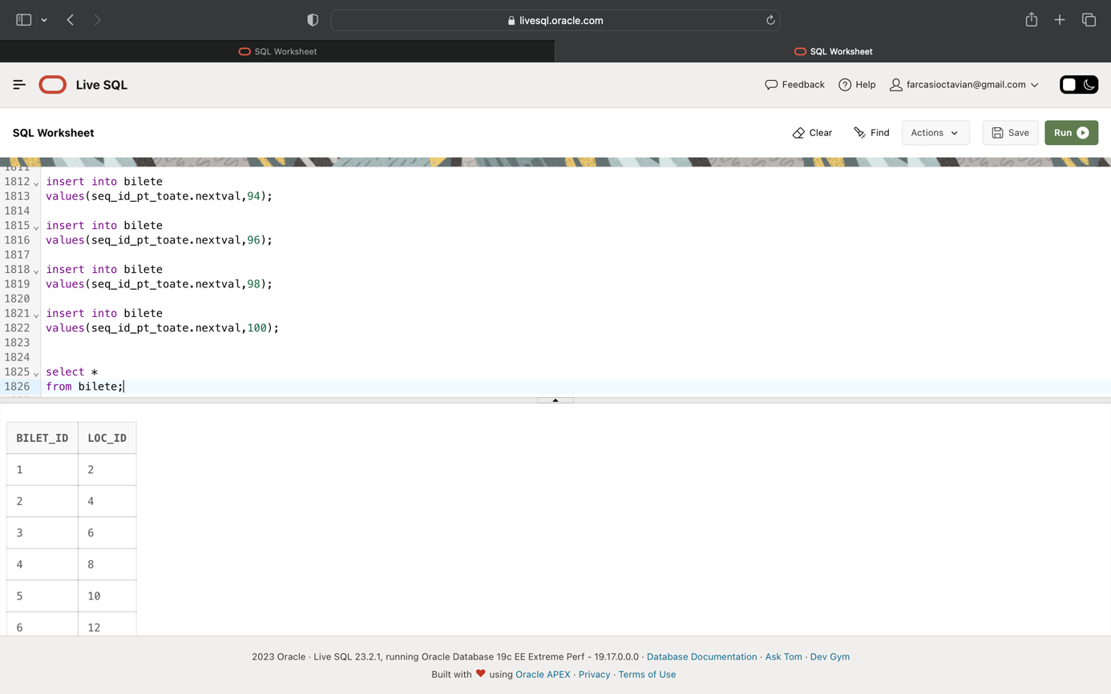

alter sequence seq_id_pt_toate restart;

insert into rezervari

values(seq_id_pt_toate.nextval,2,36);

insert into rezervari

values(seq_id_pt_toate.nextval,4,1);

insert into rezervari

values(seq_id_pt_toate.nextval,5,30);

insert into rezervari

values(seq_id_pt_toate.nextval,3,28);

insert into rezervari

values(seq_id_pt_toate.nextval,4,9);

insert into rezervari

values(seq_id_pt_toate.nextval,8,4);

insert into rezervari

values(seq_id_pt_toate.nextval,6,37);

insert into rezervari

values(seq_id_pt_toate.nextval,9,36);

insert into rezervari

values(seq_id_pt_toate.nextval,4,22);

insert into rezervari

values(seq_id_pt_toate.nextval,4,13);

insert into rezervari

values(seq_id_pt_toate.nextval,10,23);

insert into rezervari

values(seq_id_pt_toate.nextval,9,38);

insert into rezervari

values(seq_id_pt_toate.nextval,9,9);

insert into rezervari

values(seq_id_pt_toate.nextval,6,30);

insert into rezervari

values(seq_id_pt_toate.nextval,1,6);

insert into rezervari

values(seq_id_pt_toate.nextval,3,25);

insert into rezervari

values(seq_id_pt_toate.nextval,2,2);

insert into rezervari

values(seq_id_pt_toate.nextval,3,30);

insert into rezervari

values(seq_id_pt_toate.nextval,4,17);

insert into rezervari

values(seq_id_pt_toate.nextval,1,34);

insert into rezervari

values(seq_id_pt_toate.nextval,6,46);

insert into rezervari

values(seq_id_pt_toate.nextval,5,38);

insert into rezervari

values(seq_id_pt_toate.nextval,4,47);

insert into rezervari

values(seq_id_pt_toate.nextval,2,48);

insert into rezervari

values(seq_id_pt_toate.nextval,1,12);

insert into rezervari

values(seq_id_pt_toate.nextval,8,44);

insert into rezervari

values(seq_id_pt_toate.nextval,5,27);

insert into rezervari

values(seq_id_pt_toate.nextval,5,36);

insert into rezervari

values(seq_id_pt_toate.nextval,2,40);

insert into rezervari

values(seq_id_pt_toate.nextval,9,7);

insert into rezervari

values(seq_id_pt_toate.nextval,1,24);

insert into rezervari

values(seq_id_pt_toate.nextval,5,34);

insert into rezervari

values(seq_id_pt_toate.nextval,7,29);

insert into rezervari

values(seq_id_pt_toate.nextval,2,19);

insert into rezervari

values(seq_id_pt_toate.nextval,3,8);

insert into rezervari

values(seq_id_pt_toate.nextval,2,13);

insert into rezervari

values(seq_id_pt_toate.nextval,7,27);

insert into rezervari

values(seq_id_pt_toate.nextval,7,48);

insert into rezervari

values(seq_id_pt_toate.nextval,8,22);

insert into rezervari

values(seq_id_pt_toate.nextval,1,27);

insert into rezervari

values(seq_id_pt_toate.nextval,6,17);

insert into rezervari

values(seq_id_pt_toate.nextval,3,12);

insert into rezervari

values(seq_id_pt_toate.nextval,7,42);

insert into rezervari

values(seq_id_pt_toate.nextval,3,23);

insert into rezervari

values(seq_id_pt_toate.nextval,5,33);

insert into rezervari

values(seq_id_pt_toate.nextval,7,19);

insert into rezervari

values(seq_id_pt_toate.nextval,9,45);

insert into rezervari

values(seq_id_pt_toate.nextval,5,12);

insert into rezervari

values(seq_id_pt_toate.nextval,9,40);

insert into rezervari

values(seq_id_pt_toate.nextval,7,13);

insert into rezervari

values(seq_id_pt_toate.nextval,7,8);

insert into rezervari

values(seq_id_pt_toate.nextval,7,14);

insert into rezervari

values(seq_id_pt_toate.nextval,7,49);

insert into rezervari

values(seq_id_pt_toate.nextval,2,5);

insert into rezervari

values(seq_id_pt_toate.nextval,3,18);

insert into rezervari

values(seq_id_pt_toate.nextval,2,11);

insert into rezervari

values(seq_id_pt_toate.nextval,4,44);

insert into rezervari

values(seq_id_pt_toate.nextval,5,45);

insert into rezervari

values(seq_id_pt_toate.nextval,10,18);

insert into rezervari

values(seq_id_pt_toate.nextval,6,10);

insert into rezervari

values(seq_id_pt_toate.nextval,4,11);

insert into rezervari

values(seq_id_pt_toate.nextval,8,10);

insert into rezervari

values(seq_id_pt_toate.nextval,9,41);

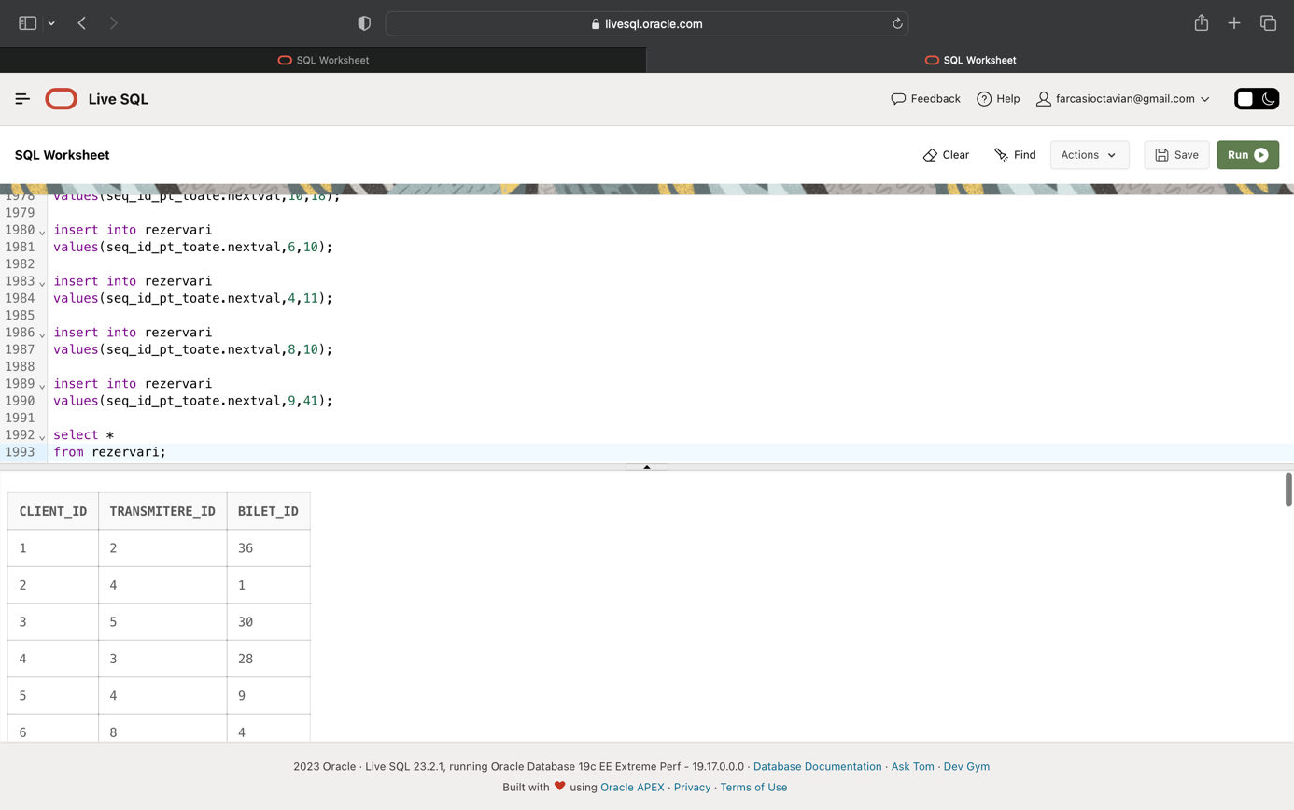

# **12.Formulați si implementați 5 cereri SQL complexe.**

Ex1: Sa se afiseze codul, numele si prenumele concatenate, salariul, numele sectiunii si durata turei celor mai puțin platiti angajati din fiecare sectiune care au in componenta numelui litera A.

•subcereri sincronizate în care intervin cel puțin 3 tabele

•utilizarea a cel puțin 2 funcții pe șiruri de caractere

select a.angajat_id, a.nume_angajat||' '||a.prenume_angajat, a.salariu, s.nume_sectiune, t.durata

from angajati a, sectiuni_lucru s, ture_angajati t

where a.sectiune_id=s.sectiune_id and a.tura_id=t.tura_id and

a.salariu=(select min(salariu)

from angajati

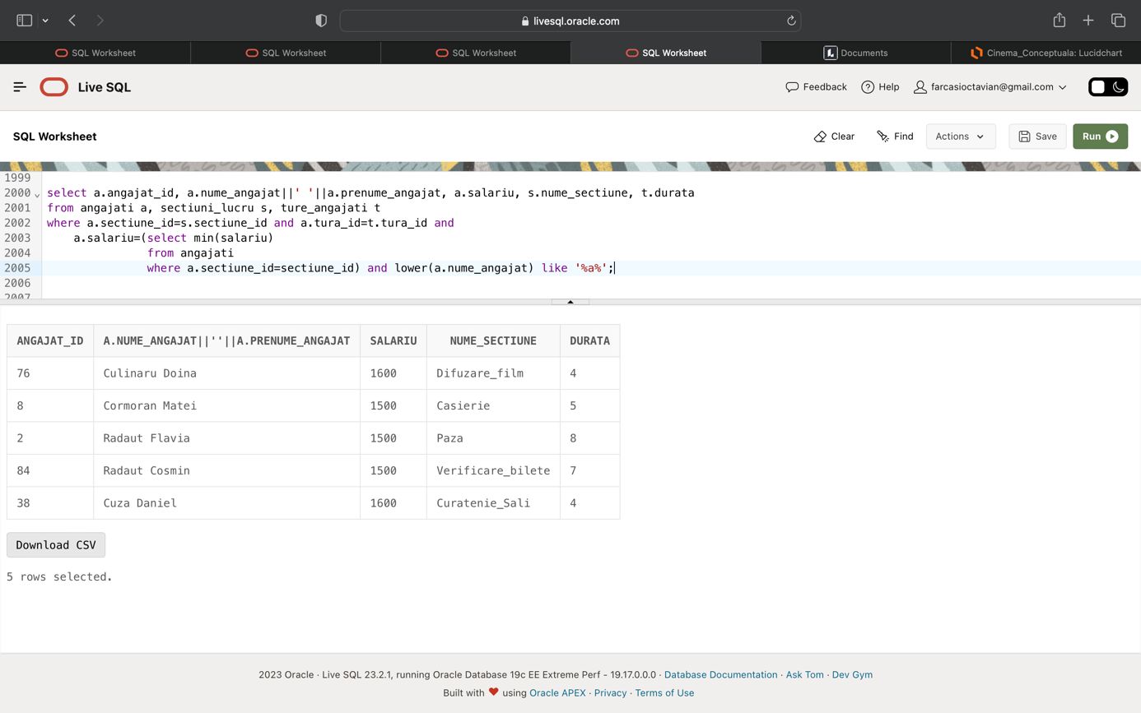 where a.sectiune_id=sectiune_id) and lower(a.nume_angajat) like '%a%';

Ex2: Sa se afiseze sectiunile, impreuna cu suma tuturor salariilor, si numarul de ture din acea sectiune, care au suma si numarul de ture mai mari decat minimul sumelor salariilor si numarul de ture al sectiunilor a caror denumire au lungimea cel mult 13. Rezultatul sa fie ordonat dupa suma salariilor.

•grupări de date cu subcereri nesincronizate in care intervin cel putin 3 tabele, funcții grup, filtrare la nivel de grupuri(in cadrul aceleiasi cereri)

•utilizarea a cel puțin 2 funcții pe șiruri de caractere

•utilizarea a cel puțin 1 bloc de cerere(clauza WITH)

•ordonari

with tab as(

select s.nume_sectiune, sum(a.salariu) suma, count(tur.tura_id) nr_ture

from angajati a, sectiuni_lucru s, ture_angajati tur

where a.sectiune_id=s.sectiune_id and length(s.nume_sectiune)<=13 and tur.tura_id=a.tura_id

group by s.nume_sectiune)

select s.nume_sectiune,sum(a.salariu) suma_totala, count(tur.tura_id) nr_ture_totale

from angajati a, sectiuni_lucru s, ture_angajati tur

where a.sectiune_id=s.sectiune_id and tur.tura_id=a.tura_id

group by s.nume_sectiune

having sum(a.salariu)>(select min(t.suma)

from tab t) and count(tur.tura_id)> (select min(t.nr_ture)

from tab t)

order by suma_totala;

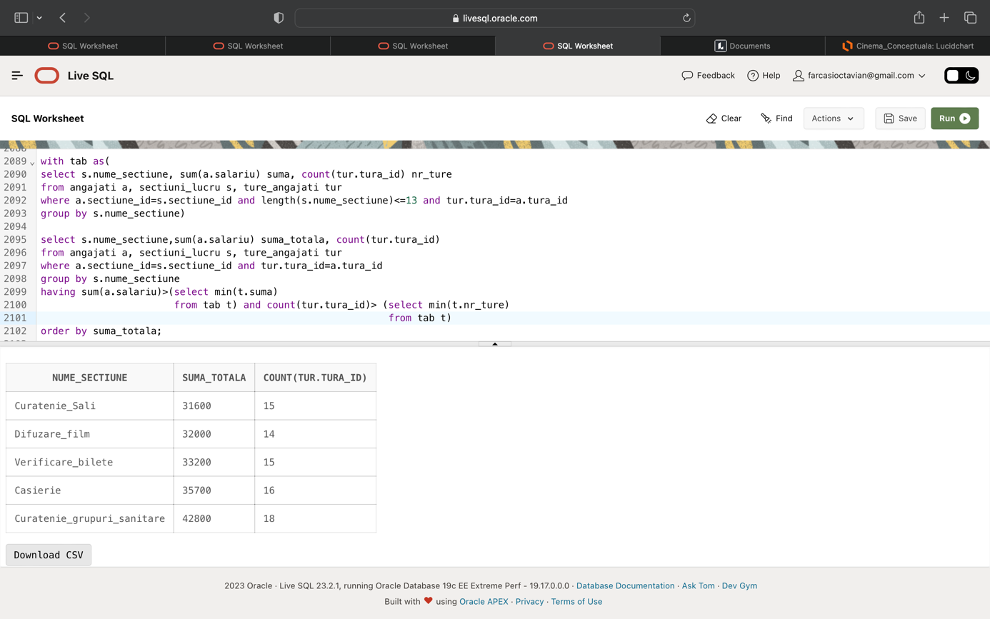

Ex3: Sa se afiseze numele, prenumele, telefonul si email-ul clientilor ce au domeniul yahoo. Pentru clientii ce nu au specificat prenumele, sa se inlocuiasca cu „anonim”, iar pentru cei ce nu au specificat numarul de telefon, sa se inlocuiasca cu „necunoscut”. Sa se ordoneze dupa nume.

•subcereri nesincronizate în clauza FROM

•ordonări si utilizarea funcțiilor NVL și DECODE (in cadrul aceleiasi cereri)

select nume_client, prenume, decode(telefon, NULL, 'necunoscut',telefon) telefon, email

from (select nume_client,nvl(prenume_client,'anonim') prenume,telefon, email

from clienti

where lower(email) like '%@yahoo%') aux

order by 1;

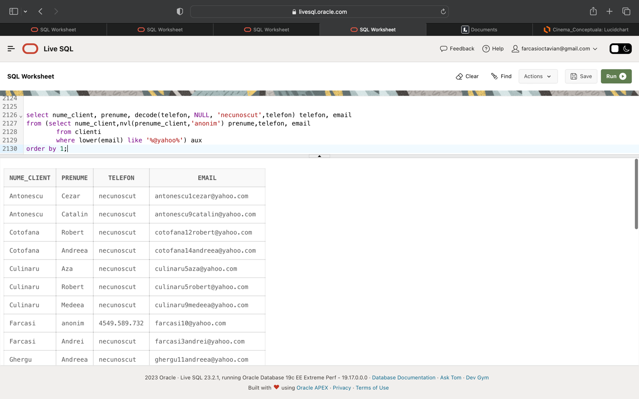

Ex4: Sa se afiseze codul clientului, numele snack-ului cumparat si un mesaj corespunzator, comparand pe cazuri diferenta dintre data curenta si data tranzactiei cu 10. Ordonati dupa prima coloana.

•utilizarea a cel puțin 2 funcții pe date calendaristice, a cel puțin unei expresii CASE

select c.client_id, s.nume_snack, t.data,case

when trunc(sysdate)-t.data>10 then 'Tranzactie de peste 10 zile'

when trunc(sysdate)-t.data=10 then 'Tranzactie a fost facuta acum 10 zile'

else 'Tranzactie recenta'

end diferenta

from tranzactii t, clienti c, snacks_uri s

where c.client_id=t.client_id and s.snack_id=t.snack_id

order by 1;

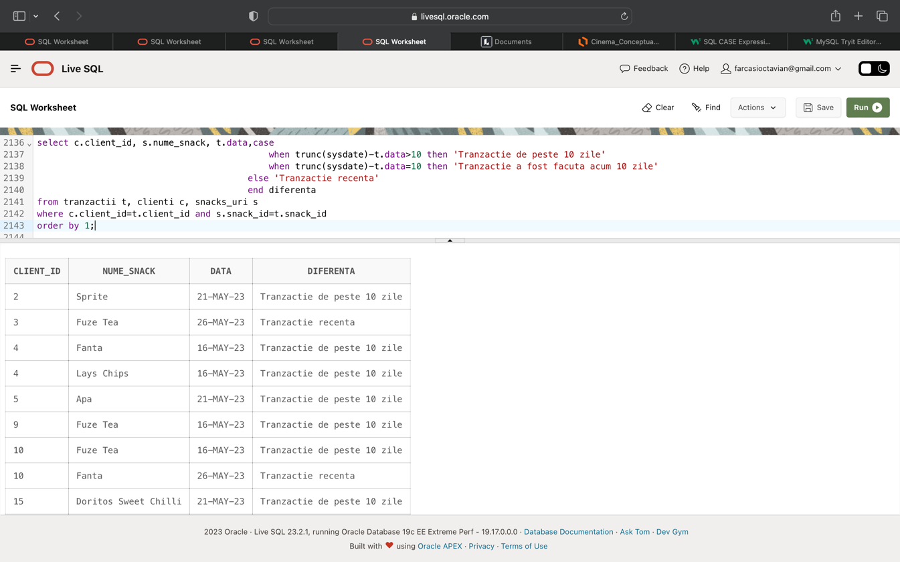

Ex5: Sa se afiseze datele si datele ce vor fi peste 3 luni, de la data tranzactiilor in care clientii au cumparat una dintre bauturile urmatoare: Pepsi, Fanta, Fuze Tea.

•utilizarea a cel puțin 2 funcții pe date calendaristice

•utilizarea a cel puțin 2 funcții pe șiruri de caractere

select t.data,add_months(t.data,3) "Peste 3 luni"

from tranzactii t, clienti c, snacks_uri s

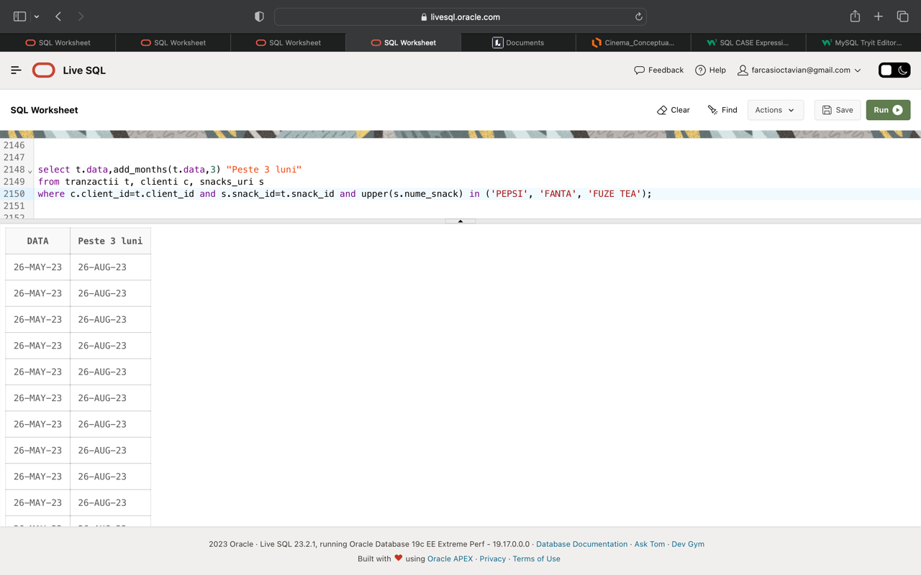where c.client_id=t.client_id and s.snack_id=t.snack_id and upper(s.nume_snack) in ('PEPSI', 'FANTA', 'FUZE TEA');

# **13.Operații actualizare și suprimare.**

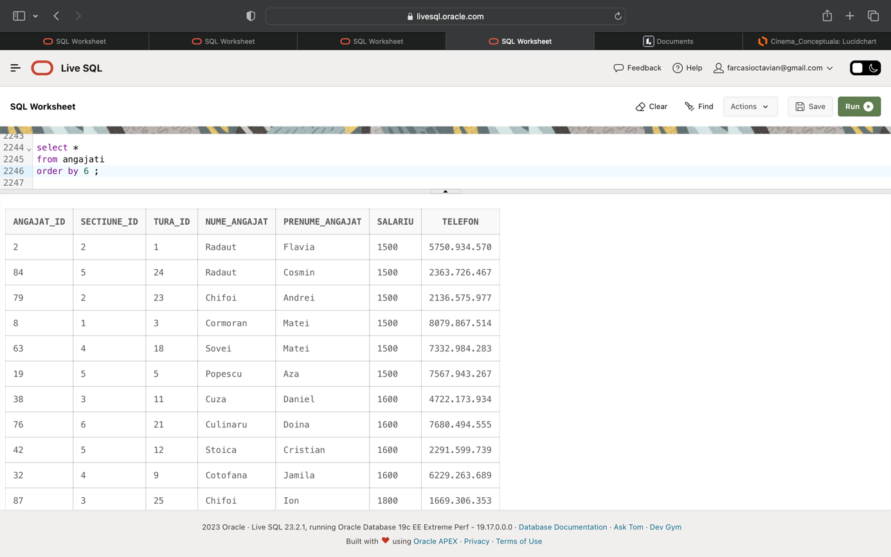Ex1: Sa se stearga angajatii care au salariul mai mic de 1700 RON si prima litera din numele lor este „c”.

delete from angajati

where angajat_id in (select angajat_id from angajati

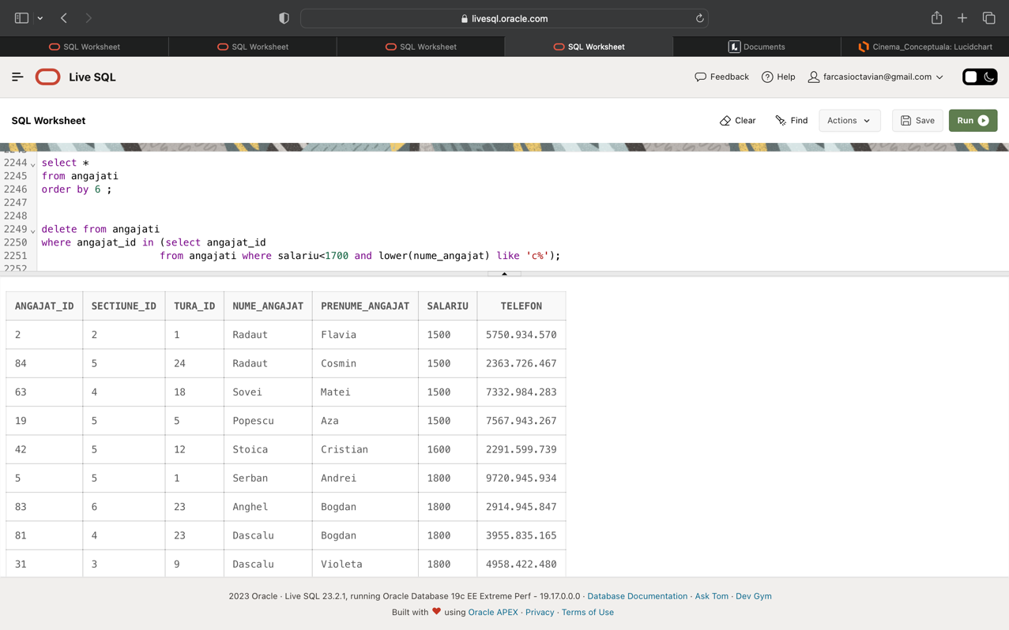 where salariu<1700 and lower(nume_angajat) like 'c%');

Ex2: Sa se dubleze pretul celor mai ieftine snacks-uri.

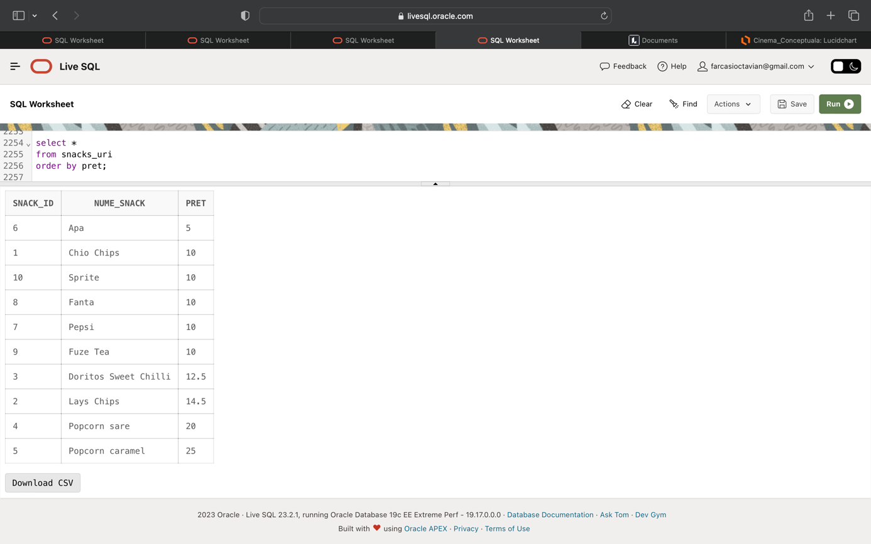

update snacks_uri

set pret=pret*2

where pret=(select min(pret)

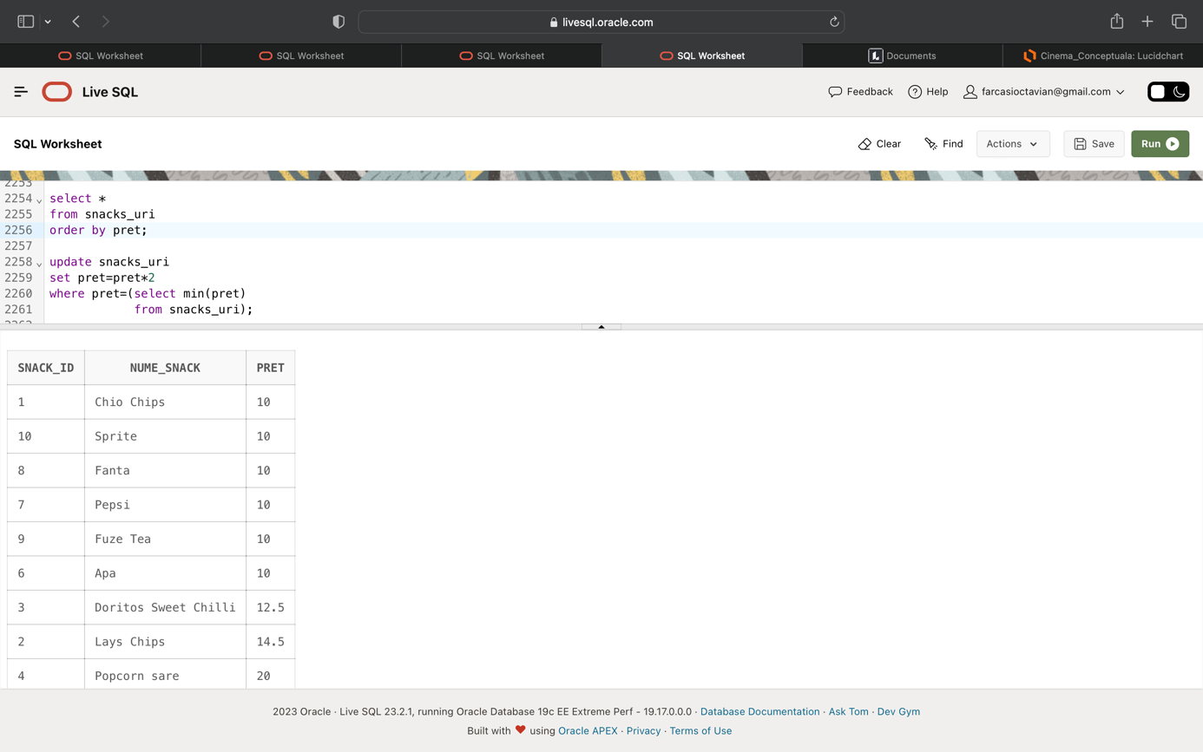 from snacks_uri);

Ex3: Sa se mareasca cu o ora in plus, durata turelor angajatiilor ce au salariul maxim si durata turei nu este 8

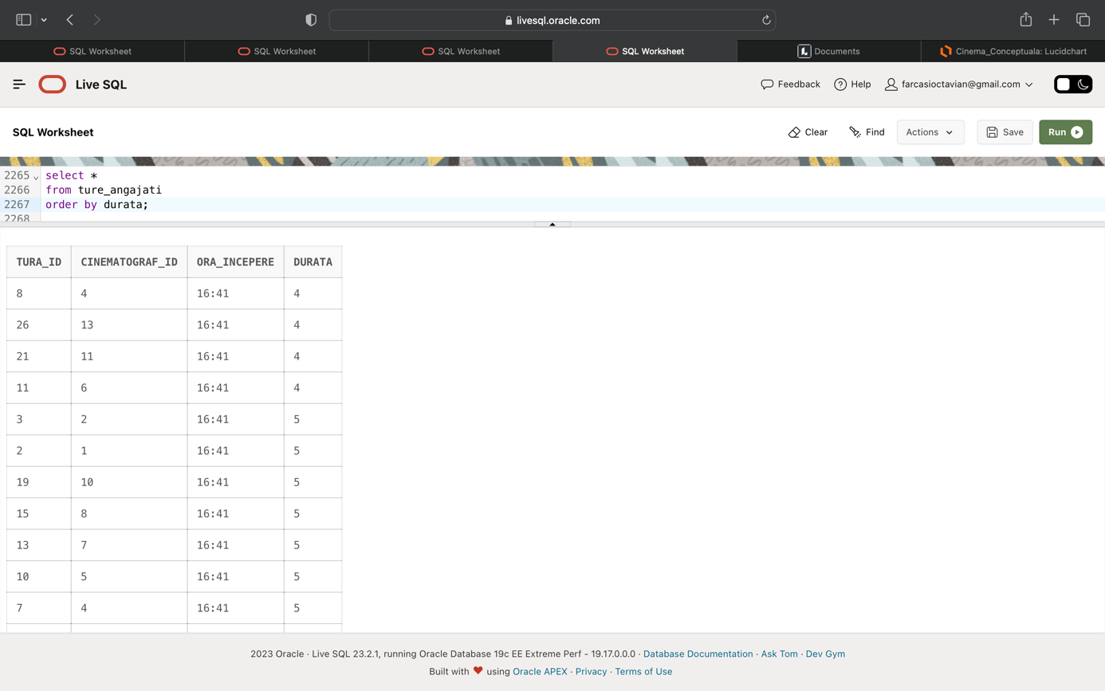

update ture_angajati

set durata=durata+1

where tura_id in (select t.tura_id

from ture_angajati t, angajati a

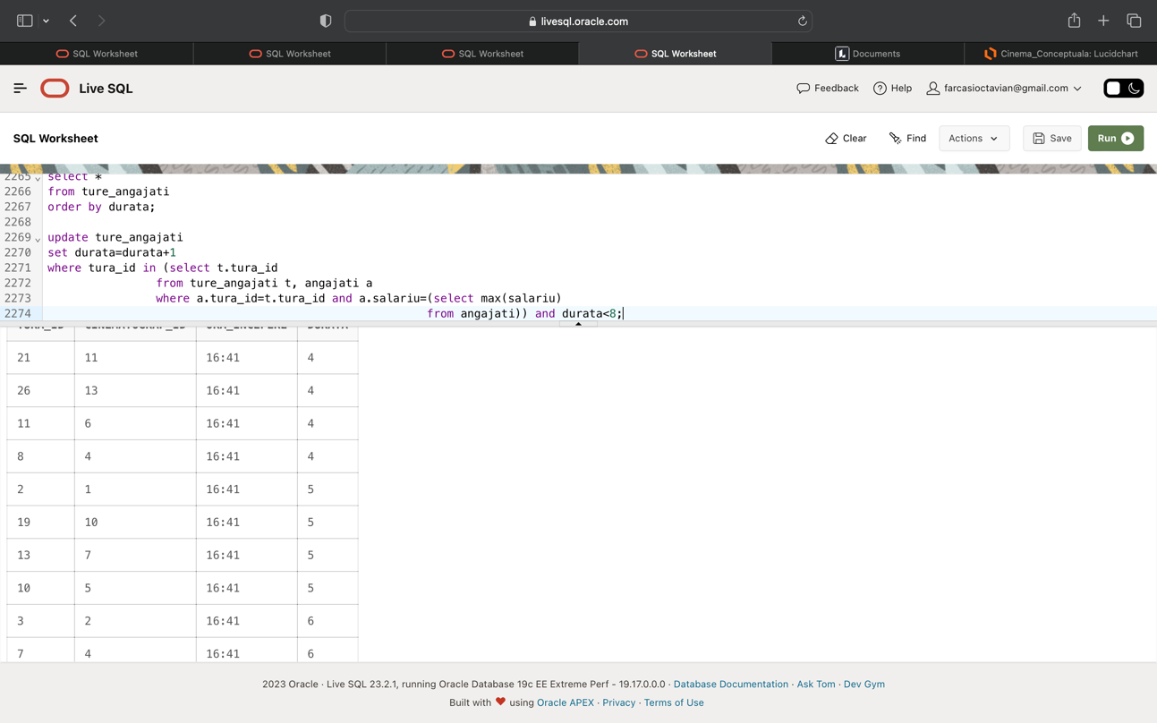 where a.tura_id=t.tura_id and a.salariu=(select max(salariu) from angajati)) and durata<8;

# **15.Operația outer-join.**

Ex1: Sa se afiseze toate numele filmelor si snacks-urilor, toate codurile salilor, clientilor, transmiterilor, folosind outer join.

select distinct f.nume_film, s.sala_id, c.client_id, t.transmitere_id, tr.client_id, sn.nume_snack

from filme f, sali_cinematograf s, clienti c, transmiteri t, rezervari r, tranzactii tr, snacks_uri sn

where f.film_id=t.film_id(+) and

s.sala_id=t.sala_id(+) and

t.transmitere_id=r.transmitere_id and

c.client_id=r.client_id and

c.client_id=tr.client_id(+) and

sn.snack_id=tr.snack_id(+)

order by 6;

